Annual Progress Seminar Report on
Development and Validation of Narrow-Aisle Robotic and IoT-Based Systems for Warehouse Management
(On completion of first year of PhD)
by
ARITRA DAS
Roll No: 25D0074
Under the supervision of
PROF. AMBARISH KUNWAR

Department of Biosciences and Bioengineering
Indian Institute of Technology Bombay
Mumbai, Maharashtra
Acknowledgement
I would like to express my sincere gratitude to my supervisor, Prof. Ambarish Kunwar, for his guidance, for the freedom he allowed me in choosing how to approach this work, and for his patience through a first year in which a great deal of the effort went into finding out what did not work. The direction this project has taken owes a great deal to his suggestions.
I gratefully acknowledge the support of the IITB-FedEx ALFA, Centre for Advanced Logistics and Focused Analytics, Indian Institute of Technology Bombay, under whose fellowship this work was carried out.
I am grateful to the members of the laboratory for their help throughout the year, and for the earlier work on asymmetric wheel geometry carried out in this group, on which the platform reported here is built. I would also like to thank everyone who assisted with the environmental monitoring work, particularly on the design of the chamber the instrumentation serves.
Plagiarism Undertaking
I hereby declare that this submission is entirely my own work, presented in my own words. Any ideas, data, or wording taken from other sources have been appropriately acknowledged and cited, with full references provided. I affirm that I have followed the principles of academic honesty and integrity, and that no part of this submission involves misrepresentation, fabrication, or falsification of information or sources. I understand that failure to comply with these standards may result in disciplinary action by the Institute, as well as possible legal or penal consequences from the concerned sources if proper citation or permission has not been obtained.
Aritra Das
Roll No: 25D0074
Abstract
This report covers the first year of a doctoral project that runs three strands at once: a robot that can work inside a narrow storage aisle, an instrumented environmental monitoring system for the space that robot moves through, and a proposed method for assessing the physical fatigue of the people who share that space, without asking any of them to wear anything.
The first strand is the substantial one, and most of this report is about it. A storage aisle is sized for the goods it holds and for a human picker, so a vehicle working there has centimetres of clearance rather than metres. Earlier work in this laboratory derived the kinematics for an asymmetric, non-collinear mecanum wheel layout intended for exactly that constraint, and demonstrated the principle on a small prototype. This year took that geometry to a full-scale machine of 45.54 kg, built the closed-loop velocity control it needs at every wheel, and measured what the result actually does. Four results are established against physical references rather than asserted: the velocity controller tracks to 0.040 to 0.047 rad/s root-mean-square with the wheels free and 0.066 to 0.074 under chassis weight, with no channel saturating in any recorded run; the kinematic and odometry implementations agree with an independent reference to machine precision across twenty thousand generated cases; wheel-odometry endpoint closure stays below 1 per cent of path travelled out to about 10 m; and a scan-matching front end was measured to increase pose error rather than reduce it, most sharply on a drive where the same wheels and the same scans gave 16.2 mm unmatched and 206.7 mm matched. Autonomous point-to-point navigation has been demonstrated, though within a live mapping session rather than against a saved map.
The second strand is a multi-parameter monitoring and control system, built from nothing over the same period and now deployed across four zones in two radio-isolated installations sharing one database. It drives an ultraviolet lamp and a fan from measured air condition rather than from a timer, reports over three wireless channels that run concurrently rather than as a failover chain, and recovers from a power interruption without anyone attending to it.
The third strand is, at this stage, a hypothesis and a completed literature survey. No hardware has been built and no data collected. It is carried here because the argument for it is already specific: the contact-based methods work well and are unusable on an operating floor for reasons that are practical rather than evidential, and the contactless modalities that might replace them have each been characterised alone but never fused for whole-body physical fatigue in an uncontrolled industrial setting.
Three things remain unresolved at the end of the year, and the reasons differ. A commissioning map meeting all four acceptance criteria is blocked by the size of the available test area rather than by anything on the platform. The effect of the asymmetric geometry itself is unquantified, because no matched symmetric baseline has been built. And several degrees of heading error survive every instrument currently fitted, narrowed to either an encoder or wheel-radius scale error or a rigid all-wheel slip mode, which cannot be separated without an angular-rate measurement that does not come from the wheels.
Table of Contents
Introduction 7
Motivation 7
Objectives 8
Chapter 1 The Narrow-Aisle Robot 9
1.1 Motivation 9
1.2 Review of Literature 10
1.3 The platform and its starting condition 12
1.4 The drive controller and the encoder return path 14
1.5 Kinematic model 17
1.6 Wheel-level velocity control, and where the gains came from 18
1.7 Control architecture and software integration 21
1.8 Perception, mapping and navigation 21
1.9 Analysis method 22
1.10 Results: closed-loop velocity control 23
1.11 Results: kinematics and motion estimation 24
1.12 Results: perception 26
1.13 Results: mapping, and the constraint imposed by the available workspace 27
1.14 Results: autonomous navigation 30
1.15 Operating without an inertial sensor 31
1.16 Present state of the platform 32
1.17 Conclusions on the robot 33
Chapter 2 Environmental Monitoring for the Warehouse Space 34
2.1 Motivation 34
2.2 Review of Literature 34
2.3 The unit, the enclosure and the sensors 35
2.4 The communication architecture 37
2.5 The control law and the operator dashboard 39
2.6 What is deployed, and what it does not yet establish 40
2.7 Towards warehouse management 41
Chapter 3 Contactless Assessment of Worker Fatigue 42
3.1 The problem, and the goal 42
3.2 Review of Literature 43
3.3 The framework proposed 44
3.4 How the framework would be validated 46
3.5 Work done, and what comes next 47
Chapter 4 Conclusions and Objectives for the Years Ahead 48
4.1 What the first year established 48
4.2 What remains open, and why 49
4.3 Objectives for the years ahead 49
4.4 Where the three converge 51
Bibliography 52

Introduction
Warehouse automation has grown around machines that move goods along wide, well-structured routes. The aisle itself has received far less attention, and it is the part of the building where the geometric constraint is hardest. A storage aisle is sized for the goods it holds and for a human picker, not for a vehicle, so a mobile robot working there operates in a corridor barely wider than itself. Clearance is measured in centimetres rather than in metres.
Three separate problems live in that same corridor, and this project takes all three. The first is motion: getting a machine down the aisle and back without touching anything, and knowing where it is well enough to do that without a person driving it. The second is the condition of the space itself, which is where the goods sit and where the air is least controlled. The third is the people, who walk that aisle under load for a full shift in conditions that, in Indian facilities, are often well outside anything comfortable.
They are treated here as three strands of one problem rather than three projects, and the reason is not that they share a theme. It is that they share instrumentation. Multi-sensor integration, calibration against a physical reference, real-time acquisition, and closed-loop control with interlocks that fail safe are the same engineering in all three, and a mistake made in one strand shows up as a lesson in the next. The monitoring system taught the robot work how to verify a configuration against a running system rather than against a file. The robot work taught the monitoring system that a control law has to be measured responding to a change, not inferred from a consistent snapshot.
There is a longer-range reason as well. A robot that already traverses every aisle is the obvious carrier for the sensing the second strand does from fixed points, and a facility that knows its own air condition and its own traffic is most of the way to knowing how hard its people are working. That convergence is the fourth-year ambition rather than a claim about this year, and it is deliberately placed at the end of the plan. A strand that has not been characterised on its own contributes nothing measurable to a combined system, so each one is carried until it stands up by itself.
The three are at very different stages, and the report does not pretend otherwise. The robot is built, instrumented and measured, and Chapter 1 is correspondingly long. The monitoring system is deployed and running, and Chapter 2 describes it without the same depth of characterisation, because it has not had the same depth of measurement. The fatigue strand is a hypothesis and a literature survey, and Chapter 3 says so in its first paragraph rather than dressing the position up. Chapter 4 sets out what the remaining years do with all three.

Motivation
That constraint rules out most drive configurations. A differential-drive or steered platform cannot correct a lateral offset without executing a manoeuvre, and the manoeuvre consumes longitudinal space the corridor does not have. Once such a platform is misaligned inside an aisle, recovering alignment requires either reversing out or a sequence of short forward and backward motions, both of which cost time and both of which risk contact with the racking.
Mecanum wheels remove that limitation. Each wheel carries a set of rollers mounted at forty-five degrees to the wheel axis, so the contact force has a component along the roller axis as well as along the wheel’s rolling direction. Driving the four wheels at different velocities produces net motion in any direction in the plane, including pure lateral translation and rotation about the vehicle centre, without any change in wheel orientation. A mecanum platform can therefore correct a lateral offset by translating sideways, a manoeuvre that in the ideal case requires no fore-aft travel at all.
Mecanum kinematics alone do not solve the aisle problem, because a conventional four-wheel mecanum platform places its wheels at the four corners of a rectangle. The chassis must then be wide enough to carry that rectangle, and the width of the machine is set by the wheel layout rather than by the payload. An alternative layout places the wheels non-collinearly, in a point-symmetric rather than a mirror-symmetric arrangement: one diagonal pair sits farther from the body centre along the vehicle’s long axis than the other. This arrangement preserves the three planar degrees of freedom that make mecanum drive useful while relaxing the packaging constraint that sets vehicle width.
The geometric premise for such a machine already exists. Earlier work in this laboratory derived the kinematics for an asymmetric, non-collinear mecanum layout intended for narrow aisles and demonstrated the principle on a prototype [1], and Section 1.2 sets out what that transformation is. What that work did not establish is whether the geometry survives the transition to a full-scale machine. A prototype demonstrates that the transformation between wheel and body velocity is correct. It does not show that four geared motors driving a 45.54 kg machine will track commanded velocities accurately, that the resulting pose estimate will be good enough to navigate on, or that a perception stack can be built on top without the asymmetry causing trouble. Those questions require a built machine, closed-loop control at every wheel, and measurement.
This motivates the primary strand of the work: to take the asymmetric geometry from a demonstrated principle to a characterised, autonomous, full-scale platform, and to measure what the asymmetry costs and what it delivers.
Two further considerations motivate the supporting strands. First, a warehouse robot that moves through an environment is more useful if the environment itself is measured, and the instrumentation skills involved transfer directly between the two problems: multi-sensor integration, calibration, real-time acquisition, and closed-loop control with safety interlocks are common to both. Second, the people sharing the aisle with such a machine work under measurable physical strain, and a monitoring approach that does not require them to wear anything would be deployable in a way that current methods are not.
Both of those supporting strands answer a question the first one raises but cannot settle. A robot that surveys an environment is only as useful as the measurement it carries, and a measurement that has never been calibrated against anything is not a measurement. A machine sharing an aisle with people ought to know something about the state those people are in. Neither question needs the robot to exist first, which is why both strands were started in parallel rather than queued behind it.

Objectives
Objective 1: Development and experimental characterisation of a full-scale asymmetric mecanum platform for narrow-aisle operation.
To build a full-scale mobile robot on the asymmetric non-collinear wheel geometry, to implement closed-loop velocity control at each wheel with calibrated feedforward, and to characterise the resulting trajectory-tracking and motion-estimation accuracy against independently measured physical references.
Objective 2: Localisation and autonomous navigation at corridor-width clearances.
To establish a pose estimate sufficient for autonomous operation in a corridor whose clearance is comparable to the platform’s own turning envelope, to determine what sensing that estimate requires, and to demonstrate goal-directed autonomous navigation on the built platform.
Objective 3: Quantification of the cost and benefit of the asymmetric wheel layout.
To compare the asymmetric platform against a symmetric layout of matched mass, wheel and controller parameters, and to establish whether the geometric benefit is obtained without penalty in tracking accuracy, disturbance rejection or yaw authority.
Objective 4: An instrumented, closed-loop environmental monitoring system for warehouse environments.
To design, build and deploy a multi-parameter environmental monitoring and control system that drives actuation from measured air condition rather than from elapsed time, reports over independent communication channels, and is applicable to storage, cold-chain and controlled-atmosphere environments.
Objective 5: A contactless framework for assessing worker fatigue.
To establish whether physical fatigue in warehouse workers can be assessed from contactless sensing alone, without any worn instrumentation, and to develop and validate a sensing configuration suitable for deployment on an operating floor.

Chapter 1 The Narrow-Aisle Robot

1.1 Motivation
The aisle is where inventory is counted, where goods are picked and replaced, and where the environment is least controlled. It is also precisely the space in which conventional mobile platforms are hardest to deploy, which is why current warehouse automation largely works around it rather than in it. A machine that holds its lateral position in a sub-metre corridor, carries a useful load, and knows where it is well enough to navigate without an operator would make several distinct warehouse tasks automatable on one platform: inventory scanning, environmental survey, surface disinfection, and cargo transfer between a rack and a pick point.
The geometric premise for such a machine already exists, and it was established here. What the prior work did not establish is whether the geometry survives the transition to a full-scale machine. A prototype demonstrates that the transformation between wheel and body velocity is correct. It does not show that four geared motors driving a 45.54 kg machine will track commanded velocities accurately, that the resulting pose estimate will be good enough to navigate on, or that a perception stack can be built on top of it without the asymmetry causing trouble somewhere unexpected. Those questions need a built machine, closed-loop control at every wheel, and measurement against something physical.
That is what this chapter reports: the platform as built, the control and perception layers put on top of it, and what each of those layers was measured to do. The order runs from what the machine is, through how it was made to work, to what it was found to do, and ends with an honest statement of which layers are established and which are not.

1.2 Review of Literature
Omnidirectional platforms and wheel geometry. Mecanum drive is mature as a mechanism and the symmetric four-wheel configuration is standard. Its kinematics, its singularity-free behaviour in the plane, and its sensitivity to wheel slip are all well documented. The asymmetric, non-collinear placement used here is far less common, and the prior work establishing its kinematics for narrow-aisle application is the laboratory study cited above [1]. The consequence of the asymmetry is that the yaw lever arm differs between the two diagonal pairs, so each wheel carries its own coefficient in the inverse kinematics rather than the single shared coefficient of the symmetric case.
The transformation itself is worth setting out, because everything downstream depends on it and because the difference from the symmetric case is small enough to be missed. On a symmetric platform the four wheels sit at the corners of a rectangle, every wheel is the same longitudinal distance from the body centre, and one yaw coefficient serves all four. Move one diagonal pair inward and that is no longer true. The outer pair keeps a lever arm of the outer longitudinal distance plus the half track, the inner pair gets a shorter one, and the two differ here by 14 per cent. Figure 1 is that paper’s own drawing of the two chassis variants and its kinematic schematic, and Figure 2 puts the symmetric and the non-collinear layouts side by side with the transformation each implies, at the dimensions of the machine built here. The translation terms are identical in both, which is why forward and lateral motion feel the same on either machine; only the yaw column changes. That is the whole of the difference, and it is also the whole of the risk, because a wheel driven with the wrong lever arm produces a yaw rate wrong by that 14 per cent and nothing else in the transformation gives any sign of it.
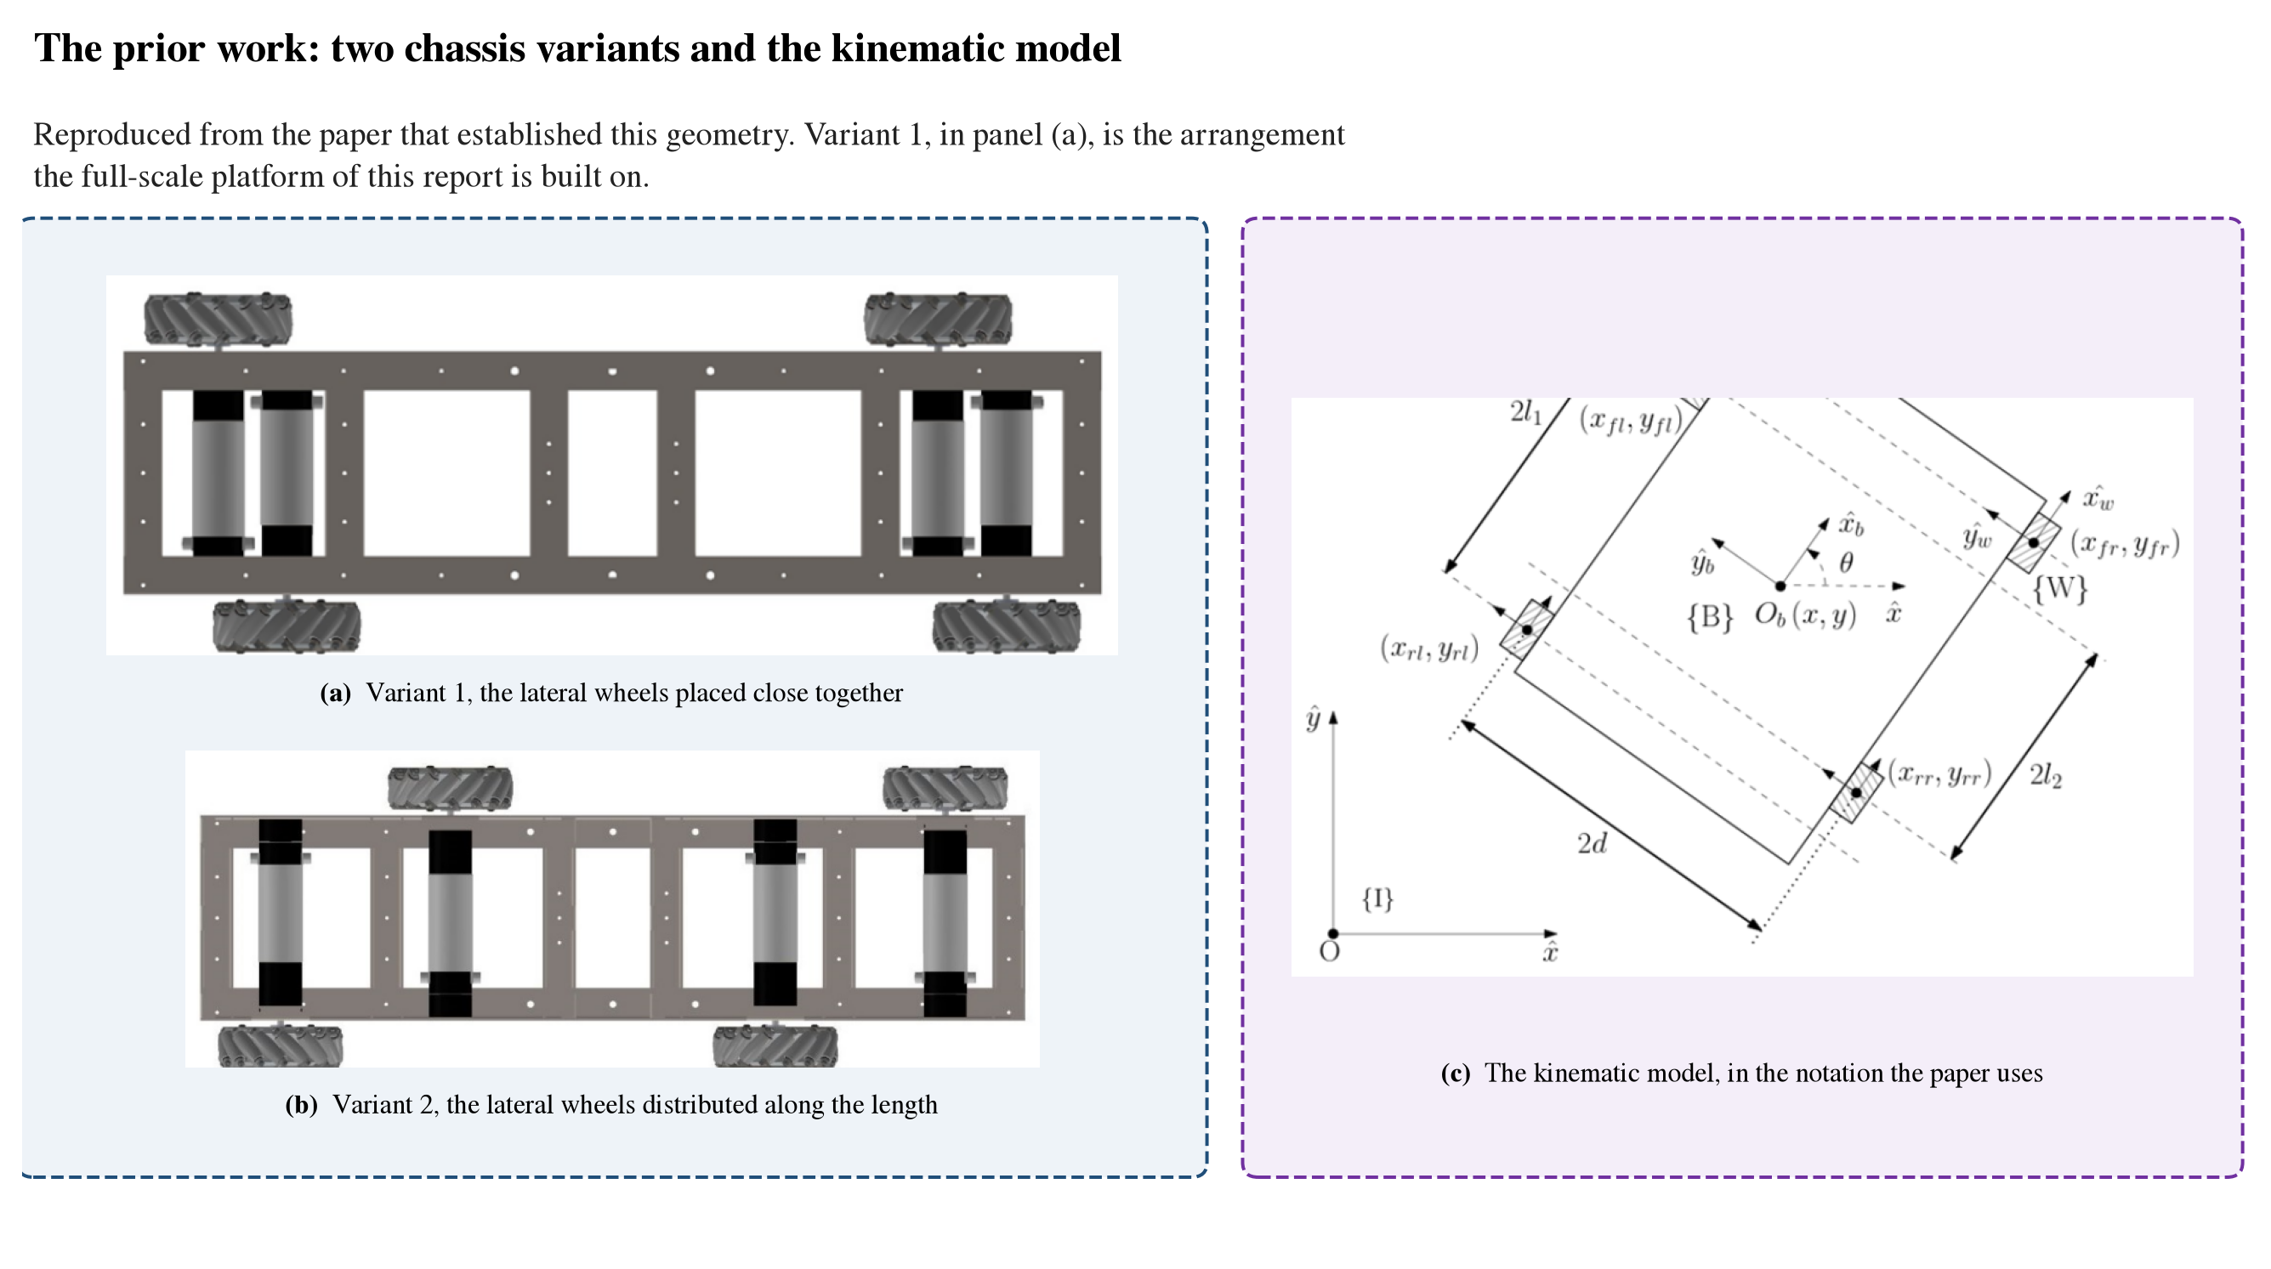
The prior work: chassis variants and the kinematic model
Figure 1. The geometry this platform inherits, reproduced from the prior work [1]. Panels (a) and (b) are the two chassis variants that paper proposes: in (a) the lateral wheels sit close together and in (b) they are distributed along the length. Variant (a) is the arrangement built here. Panel (c) is that paper’s kinematic schematic, with the wheel origins at longitudinal distances l₁ and l₂ from the body centre and a half track of d, which are the symbols used throughout Section 1.5.
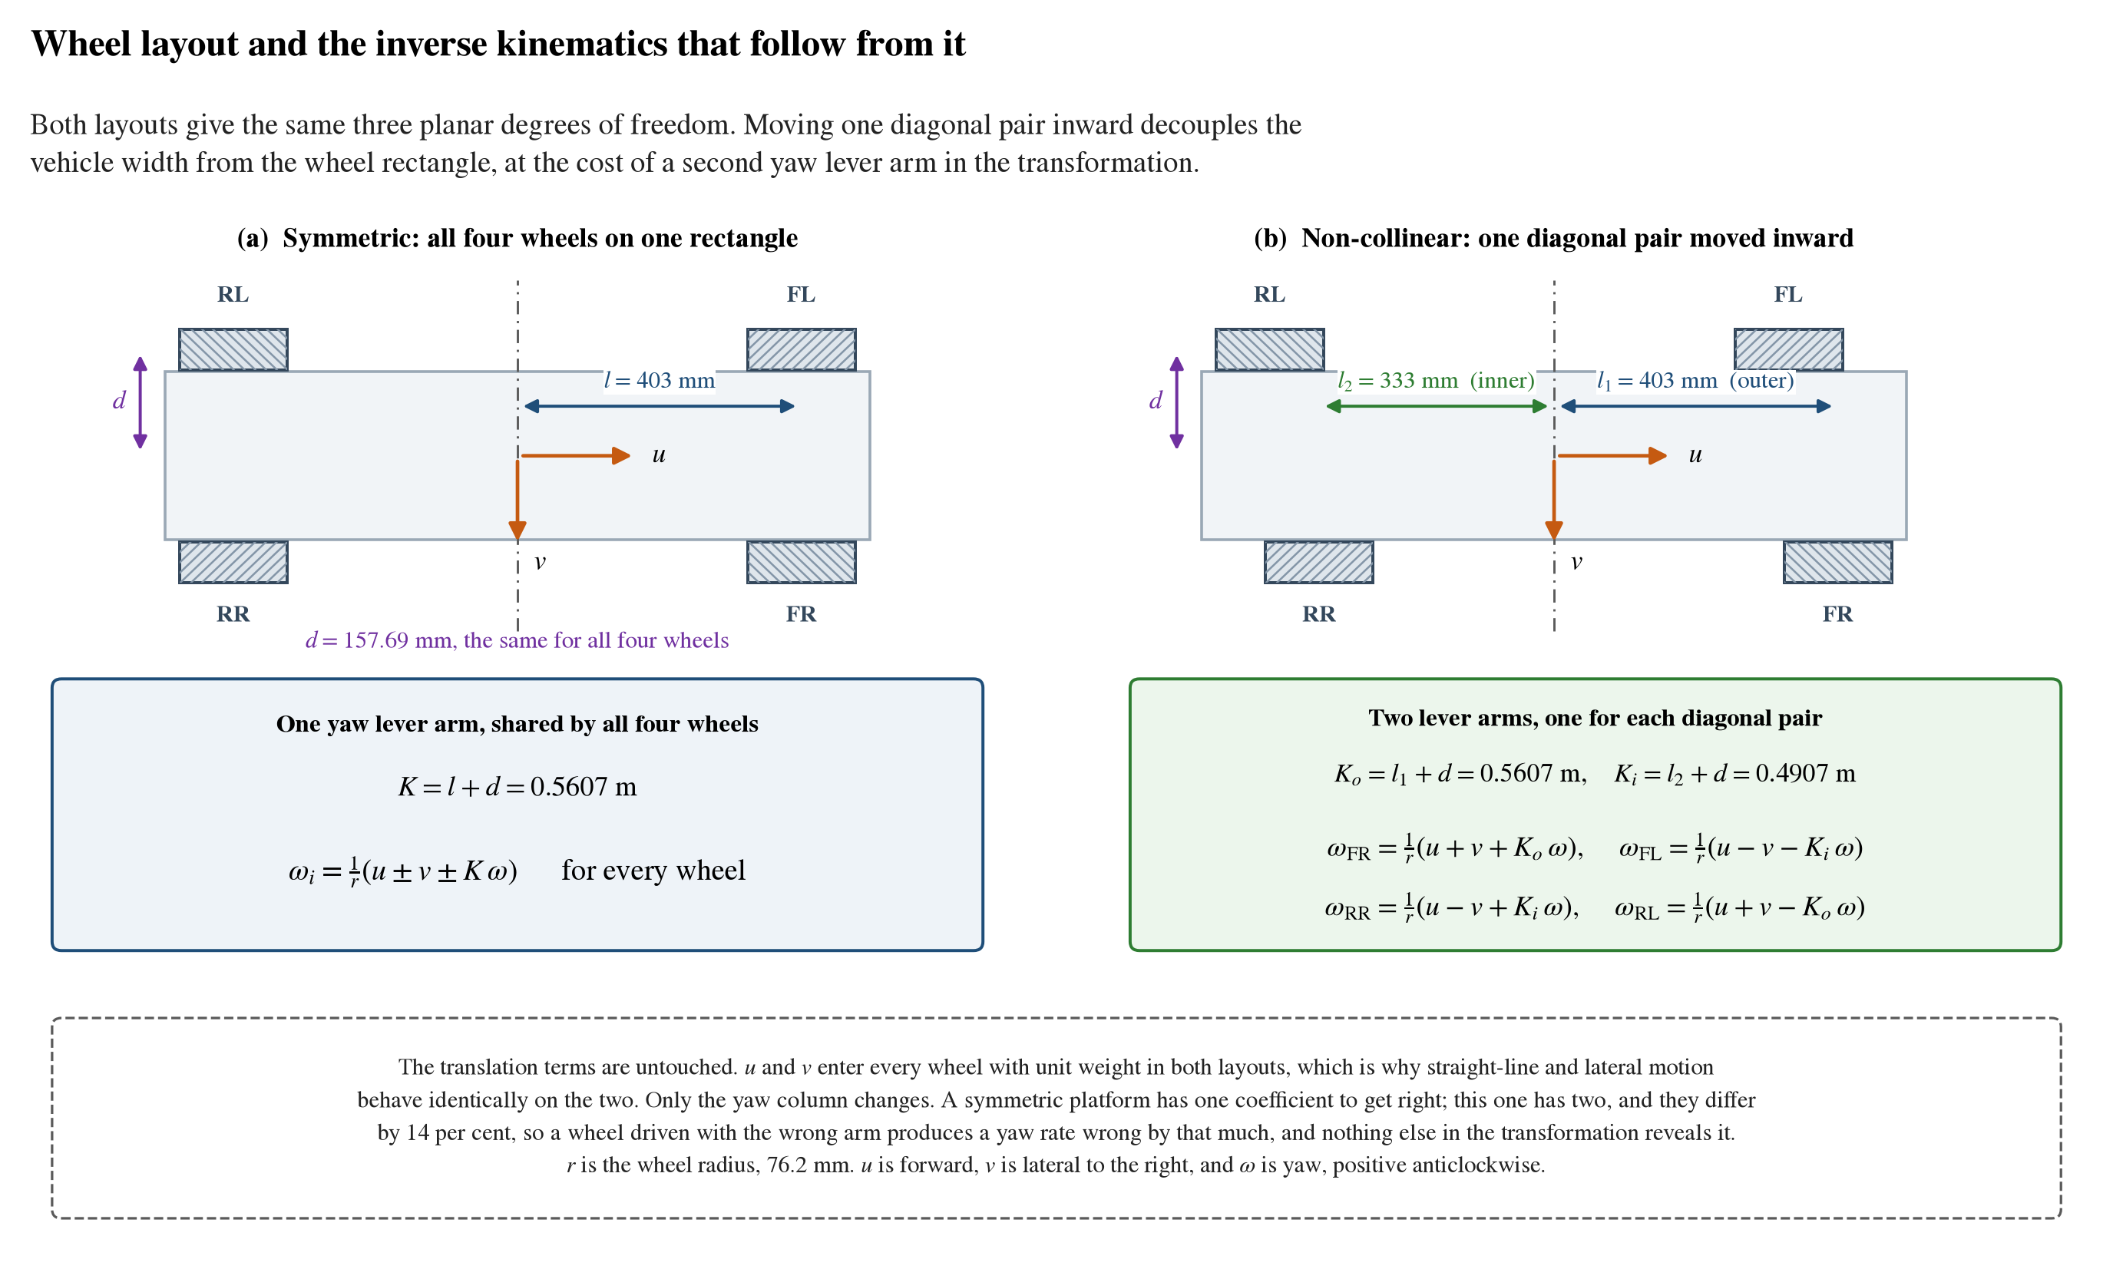
Symmetric and non-collinear wheel layouts
Figure 2. What the non-collinear placement changes, drawn at the dimensions of the machine built here. In the symmetric case every wheel shares one yaw lever arm. Moving one diagonal pair inward gives the two pairs lever arms of 0.5607 m and 0.4907 m, a difference of 14 per cent. The translation terms are identical between the two layouts, so only the yaw column of the transformation changes, and that is both the whole of the difference and the whole of the risk.
Heading drift and the need for closed-loop estimation. Wheel slip is a major source of trajectory and pose-estimation error on mecanum platforms, because the rollers present a small contact patch and slip laterally by design. Galati and co-workers drove a mecanum platform ten metres in open loop on industrial concrete and recorded heading deviations between 3.98 and 4.81 degrees across ten repetitions, with a final lateral error of 0.79 to 0.94 metres; closing the loop on the same platform and the same surface brought those to 0.40 degrees and 0.17 metres [2]. In a corridor with a few centimetres of clearance per side, an open-loop error near a metre is not degraded performance but contact with the racking, and it accumulates within a single aisle traverse. Closed-loop wheel velocity control with a measured pose estimate is therefore a requirement rather than a refinement.
Control of mecanum platforms. Fixed-gain proportional-integral-derivative control at the wheel remains the standard approach and is adequate when the plant is identified and the feedforward term is calibrated against measured data. Adaptive and fuzzy-tuned alternatives have been proposed for mecanum-wheeled platforms [3, 4], and fault-tolerant schemes exist that maintain controllability with one or two wheels disabled [5]. Both classes of work assume a symmetric wheel layout. Whether their results transfer to a platform whose wheel pairs sit at different radii from the centre of mass has not been reported.
Simultaneous localisation and mapping. Two-dimensional lidar SLAM on low-cost hardware is a well-developed field. Graph-based methods maintain a pose graph and optimise it when a place is revisited, and the widely used open-source implementation adopted here descends from that lineage [6, 10]. Particle-filter methods carry one map per particle and scale poorly on embedded hardware, which is why dedicated accelerators have been proposed for them [7, 12, 13]. Scan-matching methods without a pose-graph back end minimise drift going forward but never correct it [8]. Submap-based approaches with global matching are more capable at larger scale [9]. Comparisons on low-cost rotating scanners of the class used in this work report that scan-matching approaches outperform particle-filter methods on that sensor tier [11]. The underlying mathematics, the point-to-line matching metric [14], the nonlinear least-squares pose-graph formulation [15], and the Bayesian occupancy update [16], are standard and are applied unchanged here.
Navigation. The navigation stack used in this work provides behaviour-tree task orchestration over lifecycle-managed components, with collision checking that admits holonomic platforms rather than assuming a differential-drive motion model [17]. Its layered costmap architecture separates the inflation band, which is a cost field expressing path preference, from footprint-based collision checking, which is a separate constraint [18]. That distinction matters disproportionately in a narrow aisle, because an inflation radius chosen generously for safety can make a corridor the machine physically fits appear impassable. For local control, the dynamic-window approach searches a velocity window reachable within the robot’s acceleration limits [19], with known weaknesses in dead ends and U-shaped obstacles [20]; sampling-based predictive control evaluates many sampled trajectories against a cost function and handles omnidirectional motion more naturally [21, 22].

1.3 The platform and its starting condition
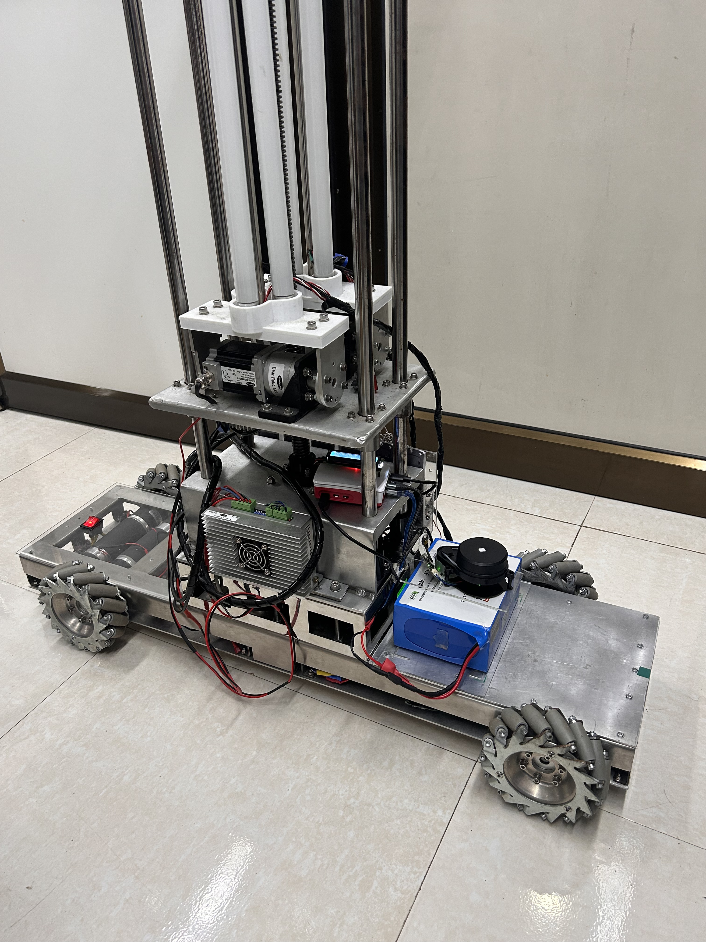
The machine as built
Figure 3. The platform as built. The chassis is 1.00 m long and 0.36 m wide across the wheels, and the four mecanum wheels sit non-collinearly rather than at the corners of a rectangle: the pair nearer the camera is visibly offset along the length from the pair behind. The vertical mast carries the three normal tubes and the stepper axis of the cargo arm. The mast and its payload sit within the plane of the lidar, which is the black unit above the battery, and are the cause of the self-occlusion sector measured in Section 1.12.
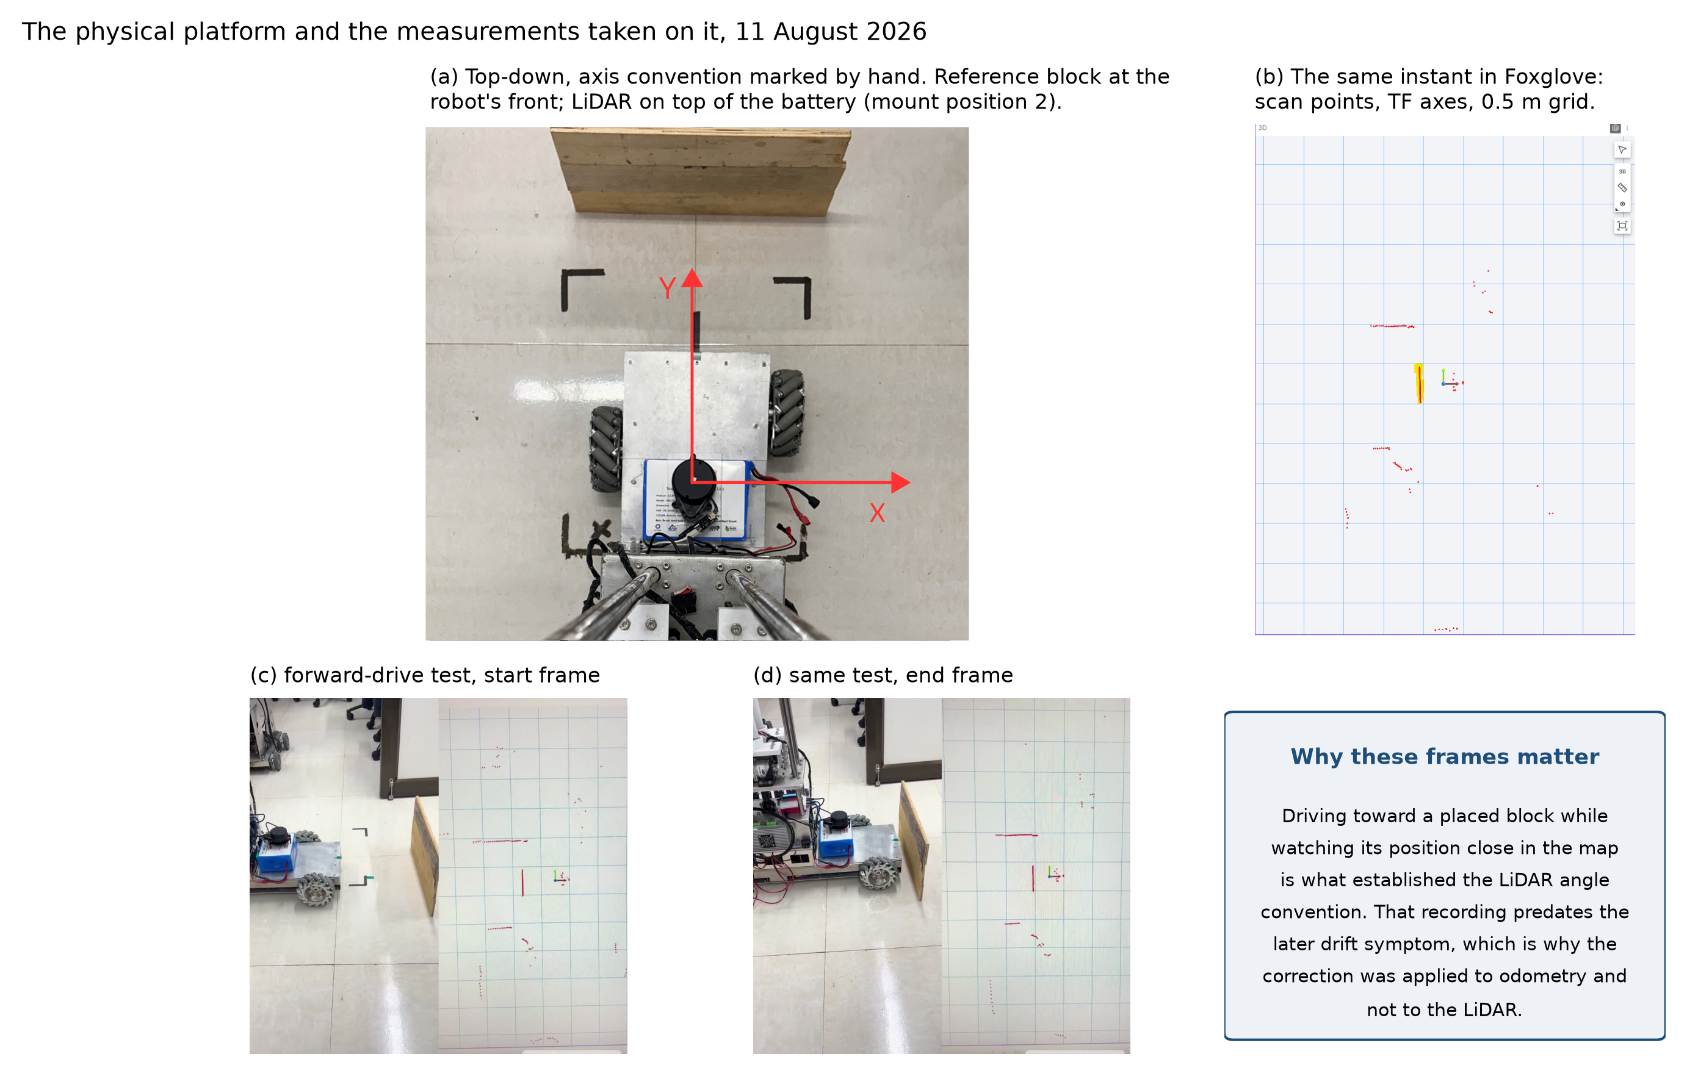
The physical platform
Figure 4. The platform during hardware trials. Panel (a) is a top-down view with the body axis convention marked and the lidar at its mounting position above the battery. Panel (b) is the corresponding view in the visualiser. Panels (c) and (d) are the start and end frames of the forward-drive test used to establish the lidar angular convention.
Work began from an assembled mechanical platform. The chassis, the four mecanum wheels on the asymmetric layout, the four geared drive motors, the two motor drivers and the power system were all present. Control of the motor drivers at that point was performed by an Arduino Mega 2560, and the platform had no closed-loop velocity regulation, no odometry, no on-board kinematic model, no perception, and no autonomy. Everything reported beyond that point, the firmware, the ROS 2 software, the instrumentation and every measurement quoted in this report, was carried out by the author.
Figures 3 and 4 show the machine as it stands. The second is worth a moment of attention. Panel (a) carries the body-axis convention used throughout this report, and panels (c) and (d) are the start and end frames of the drive that established which way the scanner counts its angles. That is the sort of thing that looks trivial once it is fixed and is expensive for as long as it is not.
The specification below describes the machine as it stands at the end of the reporting period.
Item | Value
Footprint, tape-measured | 1.00 × 0.36 m
Mass | 45.54 kg
Outer and inner wheel longitudinal distance | 0.403 m and 0.333 m
Half track width | 0.15769 m, identical for all four wheels
Wheel radius | 0.0762 m
Drive motors | 4 × geared DC, 24 V, 1:47 reduction, 60 rpm rated
Encoders | Front pair GTK08, 186,264 counts per revolution at the wheel; rear pair optical, 93,132
Motor drivers | 2 × dual-channel, 20 A continuous, 1.5 V logic threshold
Real-time controller | ESP32, 100 Hz control loop, hardware quadrature decoding
Host computer | Raspberry Pi 5, Ubuntu 24.04, ROS 2
Lidar | YDLIDAR X4 Pro, single-plane triangulation, 360°, 0.12–10 m rated range, manufacturer-stated 2 cm absolute below 1 m and 3.5 % of range from 1 to 6 m
Power | LiFePO₄ 12.8 V, 30 Ah, with boost to 24 V drive and buck to 5 V logic
Cargo arm and lighting | Two lateral and one vertical stepper axis, three-tube staged ultraviolet lighting
Operating velocity limit | 0.12 m/s linear, 0.30 rad/s yaw

1.4 The drive controller and the encoder return path
Moving motor control from the Arduino Mega to an ESP32 was the first substantial change made, and the reason is quantitative.
The two front motors carry GTK08 encoders producing 186,264 counts per revolution at the wheel, and the two rear motors optical encoders producing 93,132, in both cases after full quadrature decoding and the gear reduction. At the rated speed the output shaft turns once per second, so the four motors together emit 558,792 counted edges per second. An ATmega2560 runs at 16 MHz, which is 16 million instruction cycles per second. Servicing that edge rate in interrupts leaves approximately 29 cycles per edge for interrupt entry, register save, quadrature decode, counter update and return, before a single cycle is spent on the velocity loop, the serial protocol or the safety logic. A minimal interrupt service routine on that architecture does not fit within that budget. Encoder counting alone saturates the processor.
The ESP32 removes the problem rather than optimising around it. Its pulse counter peripheral decodes quadrature in hardware and maintains the count without processor involvement, across four independent units, one per motor. The processor is then free for the control loop, which runs at 100 Hz, and for the serial link to the host computer. Two further properties of the part were useful: substantially greater processing capability and memory than the part it replaced, and an integrated 2.4 GHz Wi-Fi radio, which allowed the first phone-based control surface to be hosted on the controller itself, before the host computer of Section 1.7 was introduced.
The controller change created an interface problem that the previous arrangement did not have. An ATmega2560 operates at 5 V logic and accepts a 5 V encoder output directly. The ESP32 does not: its input pins are 3.3 V parts with an absolute maximum close to 3.6 V, and they are not tolerant of 5 V signals. The encoders fitted to this platform produce an output close to 4.7 V. Applying the measured encoder output directly to a 3.3 V input exceeds its specified limit and risks permanent damage.
All eight encoder channels, being the two quadrature channels of each of the four motors, therefore pass through an eight-channel bidirectional level translator. The deployed hardware is a discrete-transistor board with separate low-voltage and high-voltage supply rails.
One asymmetry in this arrangement is deliberate. Only the feedback direction requires translation. The motor drivers have a logic threshold of 1.5 V and accept the 3.3 V drive and direction signals directly, so the command path runs without translation and the translator sits only on the encoder returns. Fewer components in the command path is worth having, because a fault in the command path moves the machine while a fault in the feedback path only misreports it.
Figure 5 traces the result end to end in three layers: power distribution from the battery up to the 24 V drive rail and down to the 5 V logic rail, compute and command, and drive with its odometry return. The encoder rows carry their wire colours, because the front and rear motors do not share a convention and that difference has already put a channel on the wrong pin once during commissioning.
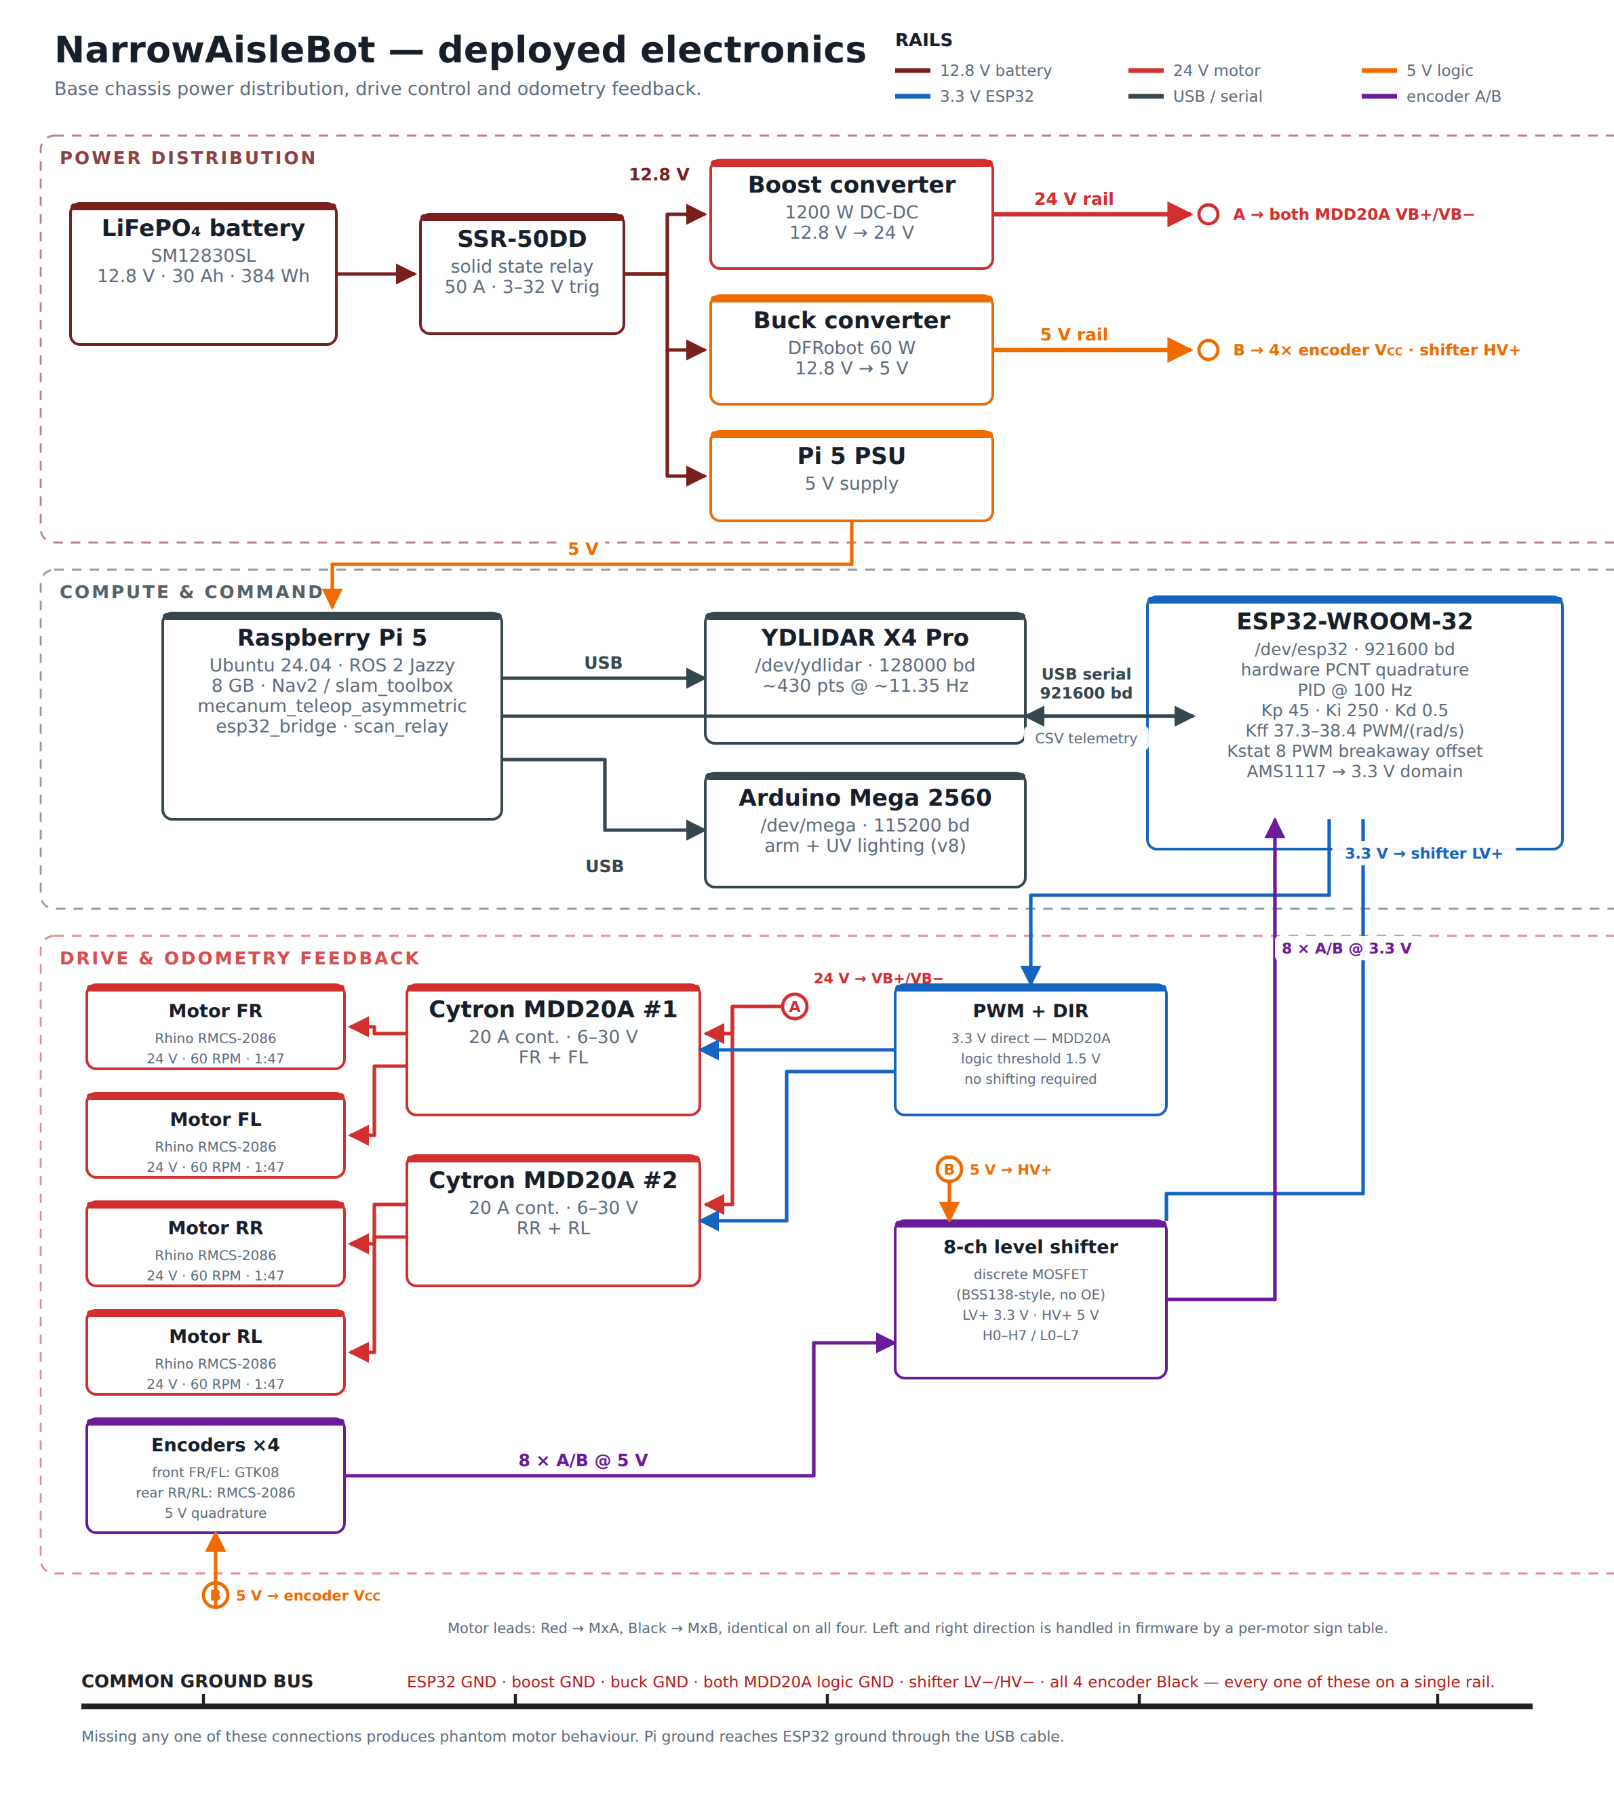
Deployed electronics
Figure 5. The deployed electronics, organised in three layers: power distribution, compute and command, and drive with odometry feedback, each on its own rail colour. The front and rear motors carry encoders of different resolution and different wiring convention, which is recorded explicitly because the difference has caused a channel to be miswired during commissioning. The control constants shown against the microcontroller are the deployed ones, and they are the values derived in Section 1.6.

1.5 Kinematic model
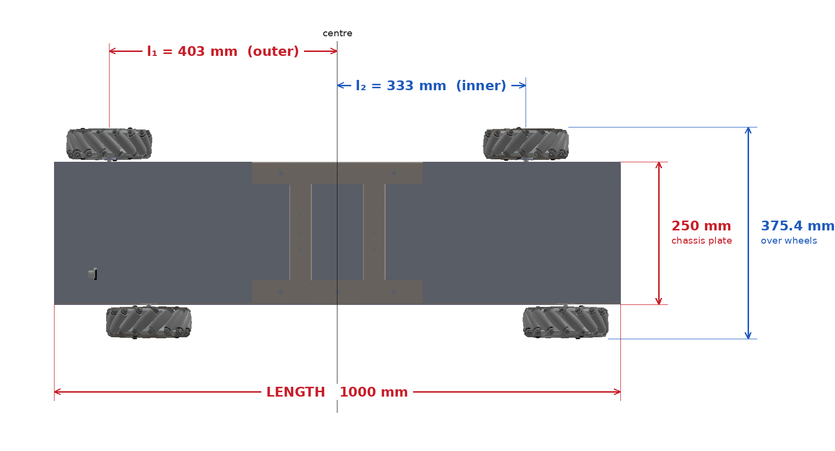
Asymmetric wheelbase geometry
Figure 6. Dimensioned plan view of the wheel layout, taken from the mechanical assembly. The outer diagonal pair sits 403 mm from the body centre along the longitudinal axis and the inner pair 333 mm, an offset of 70 mm. The half track width is the same for all four wheels. Two width figures appear in this report and they measure the same span by different means. The 360 mm quoted in the hardware table of Section 1.3, and used for the collision footprint, is the tape measurement of the built machine, wheel outer to wheel outer. The 375.4 mm marked here is derived from the assembly, being twice the 157.69 mm half track plus two 30 mm wheel half-widths. The two differ by 15.4 mm, and the tape figure is the one every experimental result in this report is referenced to.
The four wheels do not sit at the corners of a rectangle. The outer diagonal pair, front-right and rear-left, sits at a longitudinal distance l₁ = 0.403 m from the body centre; the inner pair, front-left and rear-right, sits at l₂ = 0.333 m. The half track width d = 0.15769 m is common to all four wheels and the wheel radius r is 0.0762 m. Two derived constants carry the asymmetry through every equation that follows:
Figure 6 gives those distances as they were taken off the mechanical assembly.
$K_{\text{o}}=l_{\text{1}}+d=0.5607\text{ m, }K_{\text{i}}=l_{\text{2}}+d=0.4907\text{ m}$
For a commanded body twist of forward velocity u, lateral velocity v and yaw rate ω, the four wheel angular velocities are
$ω_{\text{FR}}=1/r\left(u+v+ωK_{\text{o}}\right)\text{, }ω_{\text{FL}}=1/r\left(u−v−ωK_{\text{i}}\right)\text{,}$
$ω_{\text{RR}}=1/r\left(u−v+ωK_{\text{i}}\right)\text{, }ω_{\text{RL}}=1/r\left(u+v−ωK_{\text{o}}\right)\text{.}$
Each wheel therefore carries its own yaw coefficient, which is the practical consequence of the asymmetry. Substituting a single shared coefficient anywhere in the software reduces the machine, in that code path alone, to an ordinary symmetric mecanum platform.
Inverting this system recovers the body twist from the four measured wheel velocities, and this inverse is what the odometry integrates. The asymmetry produces one useful additional result. The first and fourth rows of the inverse kinematic matrix share the translational term and the second and third rows share its complement, so each diagonal pair yields an independent estimate of yaw rate on its own lever arm:
${\hat{ω}}_{\text{outer}}=\frac{r\left(ω_{\text{FR}}−ω_{\text{RL}}\right)}{2K_{\text{o}}}\text{, }{\hat{ω}}_{\text{inner}}=\frac{r\left(ω_{\text{RR}}−ω_{\text{FL}}\right)}{2K_{\text{i}}}$
The mean of the two is the published yaw rate. Their difference is an encoder-derived yaw-consistency residual, obtained without any additional sensor, and it is sensitive to differential wheel slip. It is not a calibrated measurement of slip alone: unequal effective wheel radii, encoder scale error, backlash and mechanical compliance all contribute to the same residual, and separating them requires an external reference.
What the asymmetry contributes here is worth stating narrowly, because it is easy to overstate. The two estimates are formed from disjoint pairs of wheels, which is what makes them separate estimates at all, rather than from the lever arms differing. They are not statistically independent, since a disturbance common to both pairs enters both. A symmetric four-wheel mecanum platform carries a residual of exactly the same form, and it does not vanish there either once slip and measurement error are present. What the differing lever arms change is the weighting. Writing each measured pair difference as its ideal value plus an error term δ, the residual is
$e_{ω}=\frac{r}{2}\left(\frac{δ_{\text{outer}}}{K_{\text{o}}}−\frac{δ_{\text{inner}}}{K_{\text{i}}}\right)$
On a symmetric platform K_o and K_i are equal, the two error terms enter with identical weight, and any component common to both pairs cancels exactly. Here they enter with different weights, so a common-mode component survives, scaled by (r/2)(1/K_o − 1/K_i), which for this geometry is 0.0097. The asymmetry therefore does not create the observable; it makes the residual sensitive to a class of error that a symmetric layout cancels, at roughly one per cent of the magnitude of that error. Whether that sensitivity is useful for drivetrain diagnostics is a question for measurement rather than for algebra, and Section 1.11 reports what the residual actually did across four drives.

1.6 Wheel-level velocity control, and where the gains came from
Velocity control runs on the ESP32 at 100 Hz, one independent loop for each of the four wheels, and Figure 7 shows the structure of a single one. The loop is not a plain proportional-integral-derivative controller, and the distinction matters for everything that follows: a two-term feedforward model supplies most of the drive from the commanded velocity alone, and the three feedback terms correct only what the feedforward gets wrong. That split is what lets the integral gain be as large as it is without the loop becoming lively.
The feedforward came first, because it was the part that could be fitted to data rather than tuned by hand. Its form is a speed-proportional term plus a static term carrying the sign of the command. The speed-proportional coefficient sits between 37.3 and 38.4 drive counts per rad/s across the four motors, a spread of 3 per cent, and the static term is 8 counts on all four. Both were fitted against three independent open-loop campaigns rather than one: a manual drive logged at steady state, an automated test sweeping demand in 1.5 s windows, and a back-calculation from an earlier closed-loop run. The reason a single-slope model will not do is visible in the data before any fitting: the ratio of drive command to resulting wheel speed rises as speed falls, which is the signature of a breakaway friction term that a straight line through the origin cannot reproduce. The two-term fit reproduces every measured point to within about 6 per cent, and Figure 8 shows it against the measurements. The static term is faded in across 0.05 to 0.20 rad/s rather than applied as a step at any non-zero command, so that a very small commanded velocity does not produce a discontinuity in the drive.
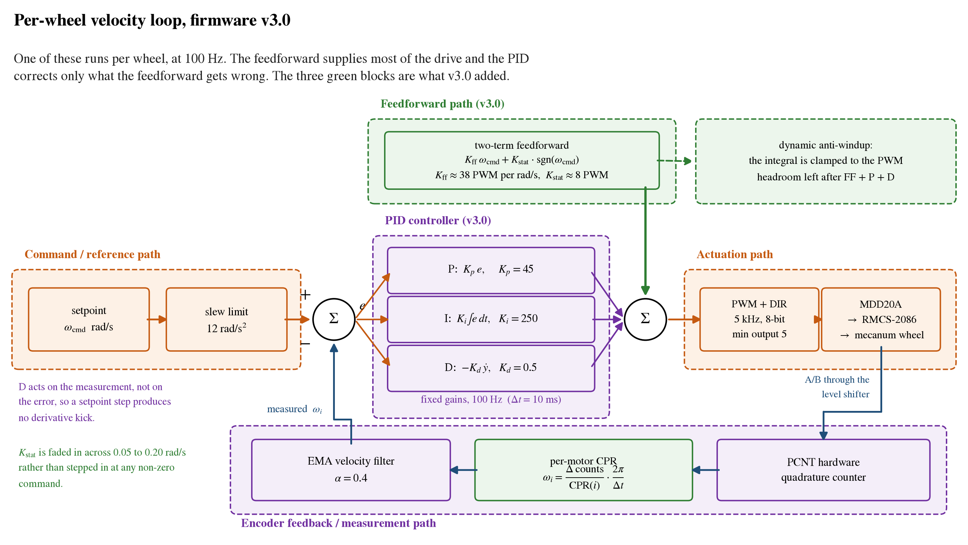
The per-wheel velocity loop
Figure 7. The per-wheel velocity loop as the deployed firmware runs it. One of these runs for each of the four wheels, at 100 Hz. The feedforward supplies most of the drive and the proportional-integral-derivative terms correct only the residual, which is why the integral gain can be as large as it is without the loop becoming lively. The derivative term acts on the measurement rather than on the error, so a step in the setpoint produces no derivative kick, and the integral is clamped to whatever command range is left after the other three terms rather than to a fixed bound.
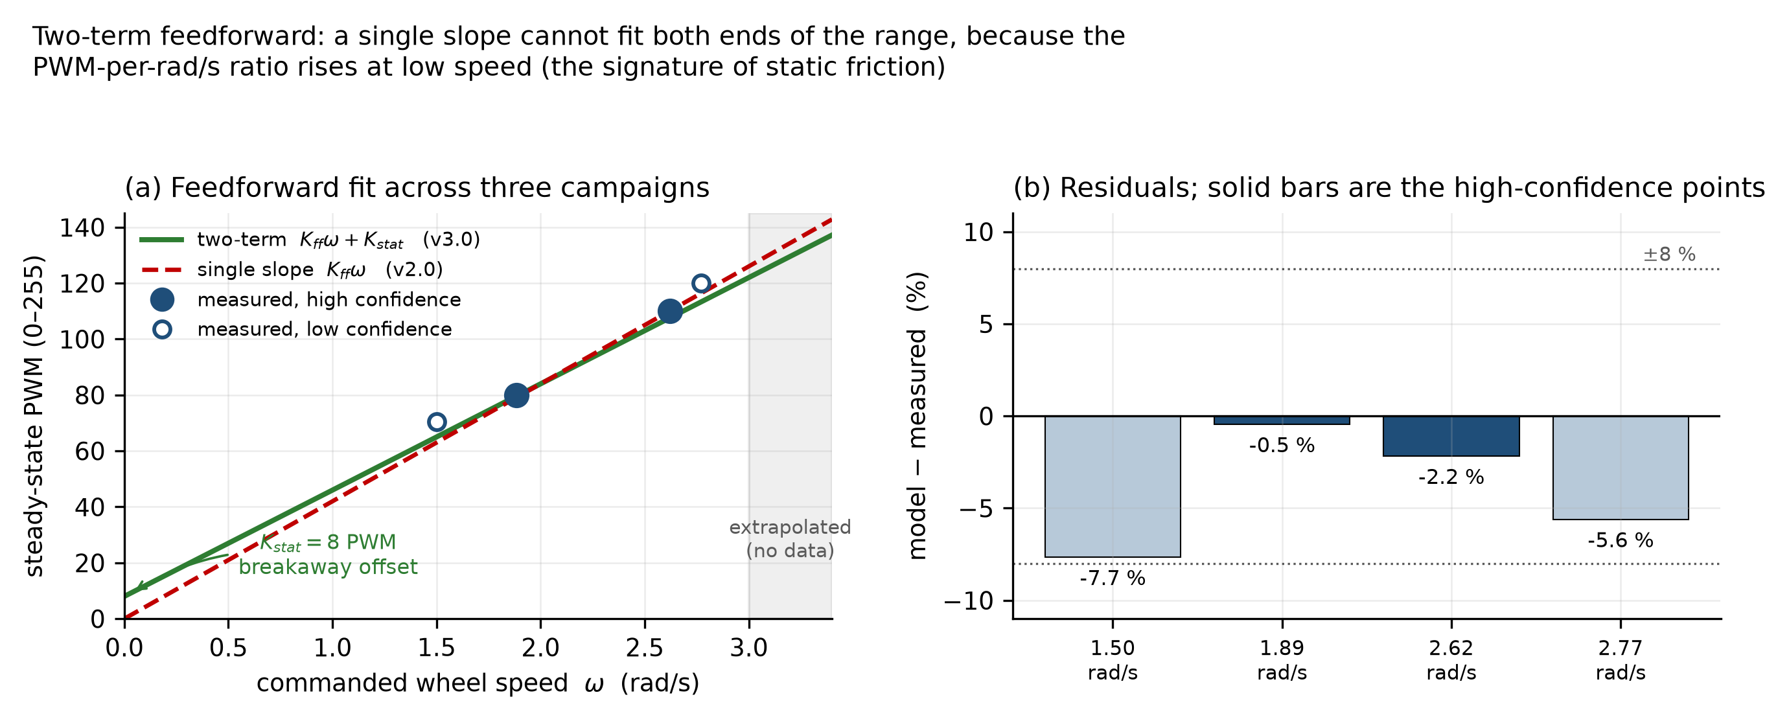
Feedforward model
Figure 8. The two-term feedforward model fitted against measured open-loop data. The static term accounts for breakaway friction and the speed-proportional term for the remaining demand. A single-slope model systematically under-drives the wheels at low speed, which is why the second term is required.
With the feedforward fitted, the plant is characterised well enough to compute the feedback gains rather than search for them. Inverting the fitted slope gives a plant gain of about 0.0263 rad/s per drive count. For a first-order plant, direct synthesis fixes the integral gain from that number and a chosen closed-loop time constant alone: the integral gain is the reciprocal of their product. A closed-loop time constant of 0.15 s was chosen, which is fifteen control periods and deliberately conservative, and it gives an integral gain of 253. The deployed value is 250.
That gain is the single largest change from the previous firmware, where it was 30. At 30 the integral moved roughly three drive counts per second, which against a feedforward error of any size is far too slow to be doing useful work: an air run in May settled in up to 3.79 s, and what was settling it was mostly the proportional term. Raising it by a factor of eight is a large change to make at once, and it was only safe because of the feedforward. When the feedforward carries the bulk of the command, the integral is correcting a small residual rather than supplying drive from zero, so a gain that would be reckless on a bare loop is appropriate here.
The proportional gain is the one number in the loop that is an estimate rather than a fit, and it is worth saying so plainly. Direct synthesis sets it as the product of the integral gain and the plant time constant, and that time constant had never been measured on this machine, because every bench run to that point had logged steady-state points and no transients. A value of 0.18 s was assumed, on the grounds that it is plausible for a 100 W motor behind a 47:1 planetary gearbox, and it gives a proportional gain of 45. The assumption was later tested. Plant identification put the real time constant at about 0.09 s, half what had been assumed, which by the same formula would call for a proportional gain of roughly 22. Two recomputed gains were then run against the gain already in service, across sixteen combinations of setpoint and motor, and both produced more overshoot. The original value was kept, on measured evidence rather than on the theory that produced it. This is the least satisfying part of the tuning and it is recorded as such: the deployed gain is right, but the argument that originally justified it turned out to rest on a number that was wrong by a factor of two.
The derivative gain is 0.5, which is small on purpose. Against a genuinely first-order plant a matched proportional-integral pair needs no derivative action at all, and everything this term is doing is damping lag that the first-order model does not contain: driver delay, compliance in the gearbox, and the velocity filter itself. Two details of how it is applied matter more than its size. It acts on the measurement rather than on the error, so a step in the commanded velocity produces no derivative kick, and it is taken through a heavier filter than the velocity signal, because differentiating amplifies whatever noise survives the first filter.
Three arrangements around the loop do more for its behaviour than the gains do. The integral is clamped dynamically, to whatever command range is left after the feedforward and the proportional and derivative terms have taken their share, rather than to a fixed bound; the previous firmware used a fixed clamp, which in combination with the low integral gain of the time allowed the integral state to reach values it could never usefully act on. The commanded velocity is passed through a slew limit of 12 rad/s squared before the loop sees it, so that a step command from the host cannot ask for an acceleration the hardware will not produce, which is the condition that drives an integrator into saturation in the first place. And the minimum drive output was lowered from 15 counts to 5. The larger value had been there to suppress audible hum, but it cut a dead zone straight through the middle of the range in which the controller does its fine regulation, and produced a limit cycle at low speed; with breakaway friction now handled properly by the static feedforward term, the threshold can sit at the level where the motor is genuinely silent.
Two limits bound what the loop is allowed to do. The velocity ceiling is 5.20 rad/s per wheel, chosen so that the worst of the four motors needs about 208 of the 255 available drive counts at that speed, leaving roughly 18 per cent of the range as authority for the feedback terms. That margin is an in-air figure and the ground measurement of Section 1.10 is the reason it has to be revisited. Separately, three trips watch every wheel: overspeed, stall, and a runaway detector that looks for a saturated command pushing one way while the wheel turns the other and does not slow down. The last of those exists for a specific failure. The drive direction sign and the encoder direction sign have to agree for each motor; if they disagree the loop sees positive feedback, and because a motor rated at 60 rpm cannot physically overspeed its way past the overspeed threshold, nothing else in the system would catch it.

1.7 Control architecture and software integration
A Raspberry Pi 5 running ROS 2 was introduced as the planning and perception computer, with the ESP32 retained for real-time control. The division follows directly from the timing argument of Section 1.4: work that must happen on a fixed schedule sits on the microcontroller, and work that benefits from an operating system sits on the host. The software developed comprises a serial bridge to the motor controller, a second bridge to the arm controller, the asymmetric teleoperation node implementing the inverse kinematics above, an odometry publisher, telemetry logging, a scan relay that republishes the lidar scan with the self-occlusion mask of Section 1.8 applied, and an operator dashboard served from the robot itself with click-to-goal command entry.
The dashboard reaches the robot without any external network. The host computer runs its own Wi-Fi access point, so a phone joins the robot directly, and one page carries the drive joystick, the yaw control, the live map and click-to-goal entry. Whichever source holds control, the asymmetric inverse kinematics of Section 1.5 are evaluated once, in the teleoperation node on the host.
An earlier arrangement hosted a joystick page on the motor controller’s own radio instead, and that was the first control surface the machine had. It was removed when the host became the single command source. That path applied one shared coefficient rather than the two the geometry requires, so it never carried the asymmetry the platform is built around, and it was also the only point at which two writers could contend for the same wheel setpoints.
The cargo arm and the three-tube staged ultraviolet lighting are retained on the original Arduino Mega, which was reassigned to the payload rather than discarded. The lighting is sequenced on that controller so that the staging survives loss of the serial link, with a latched emergency stop.

1.8 Perception, mapping and navigation
The platform carries a YDLIDAR X4 Pro, a single-plane triangulation scanner. Three properties of the installed sensor were measured rather than assumed, because each affects what the mapping layer can achieve. The scanner returns approximately 430 points per revolution at 11.35 Hz and does not respond to a commanded scan rate. The manufacturer states 2 cm absolute accuracy below 1 m and 3.5 per cent of range between 1 and 6 m, with nothing specified beyond 6 m despite a 10 m rated range. That figure is a factory acceptance condition rather than a runtime error distribution, so rather than extrapolate from it the stationary scatter of the installed unit was measured directly. The robot was parked with nothing moving in the room and every ray logged for 60 s; scatter is reported per range bin as the spread of a given bearing’s returned range across consecutive sweeps, which is a different statistic from the manufacturer’s mean relative accuracy over a fixed reflectance target. Below 1.5 m the unit is solid in both captures, at 12 to 14 mm. In the 1.5 to 2.0 m band the first capture gives 22.3 mm and a second capture, taken from a differently obstructed parking spot, gives 31.9 mm, which fails the 25 mm half-cell criterion the occupancy resolution implies. Beyond 2.5 m both captures return 55 to 200 mm and do not agree with each other. Neither a linear nor a quadratic degradation model reproduces that pattern, since both predict a single smooth curve. The behaviour is scene-dependent and is not explained by range alone in these captures, which is itself the result: a range cap derived in one position is a fact about that position until it reproduces elsewhere.
The robot occludes its own scanner over part of the sweep, because the mast and payload sit within the scan plane. The blind sector was measured at five independent headings and is a wedge of approximately 90 degrees covering 107 of the 430 returned beams. Those beams are masked in software before the scan reaches the mapping layer, because an unmasked self-return is interpreted as a stationary obstacle travelling with the robot.
Mapping uses a graph-based two-dimensional SLAM implementation, with occupancy maintained by the standard Bayesian log-odds update.
Navigation uses a behaviour-tree task orchestrator over lifecycle-managed components, with a global planner producing a route through the costmap and a local controller producing velocity commands that follow it. The collision footprint was set from tape measurement of the built machine rather than from nominal dimensions.
The local controller was changed during the work. A dynamic-window controller was adopted first, on the reasoning that it is computationally lighter. It was replaced with a sampling-based predictive controller after the deployed dynamic-window configuration was found to stall on rotation-only goals. Its rotate-to-goal critic invalidates candidates carrying translational motion in the final phase, and because that configuration sampled velocities on a full cross-product grid, only a small fraction of candidates survived the test. This is a property of the configuration rather than of the dynamic-window approach as such: the critic’s behaviour depends on the goal tolerance, the velocity sample set and the simulation horizon, none of which were varied before the controller was replaced. The replacement evaluates sampled trajectories additively against a cost function, so that particular failure mode cannot arise, and it samples the lateral axis directly rather than as a coarse discretisation, which suits an omnidirectional platform.
Commands from the planner, from the operator dashboard and from the manual joystick converge through a priority multiplexer into the same inverse kinematics, so that manual override outranks the planner at the single point where the two meet.

1.9 Analysis method
Every recorded drive is analysed offline by a purpose-built set of analysis tools rather than by inspection. These recompute position and slip from the raw encoder record independently of the live estimate, grade a saved map against stated acceptance criteria, measure scan-to-scan stability of the lidar returns, and verify that the coordinate frame convention holds across the software. Building these was necessary because several of the faults encountered during the work produced entirely normal-looking telemetry, and could not have been found by observing the robot.
Two conventions were adopted after early errors and are stated here because they shaped the results. Configuration is verified by querying the running system rather than by reading a configuration file, and a prediction is written down before a test rather than after it.

1.10 Results: closed-loop velocity control
Figure 9 shows what the loop does to a commanded step with the wheels off the ground, and Figure 10 shows what happens to the steady-state demand when the chassis weight goes back on.
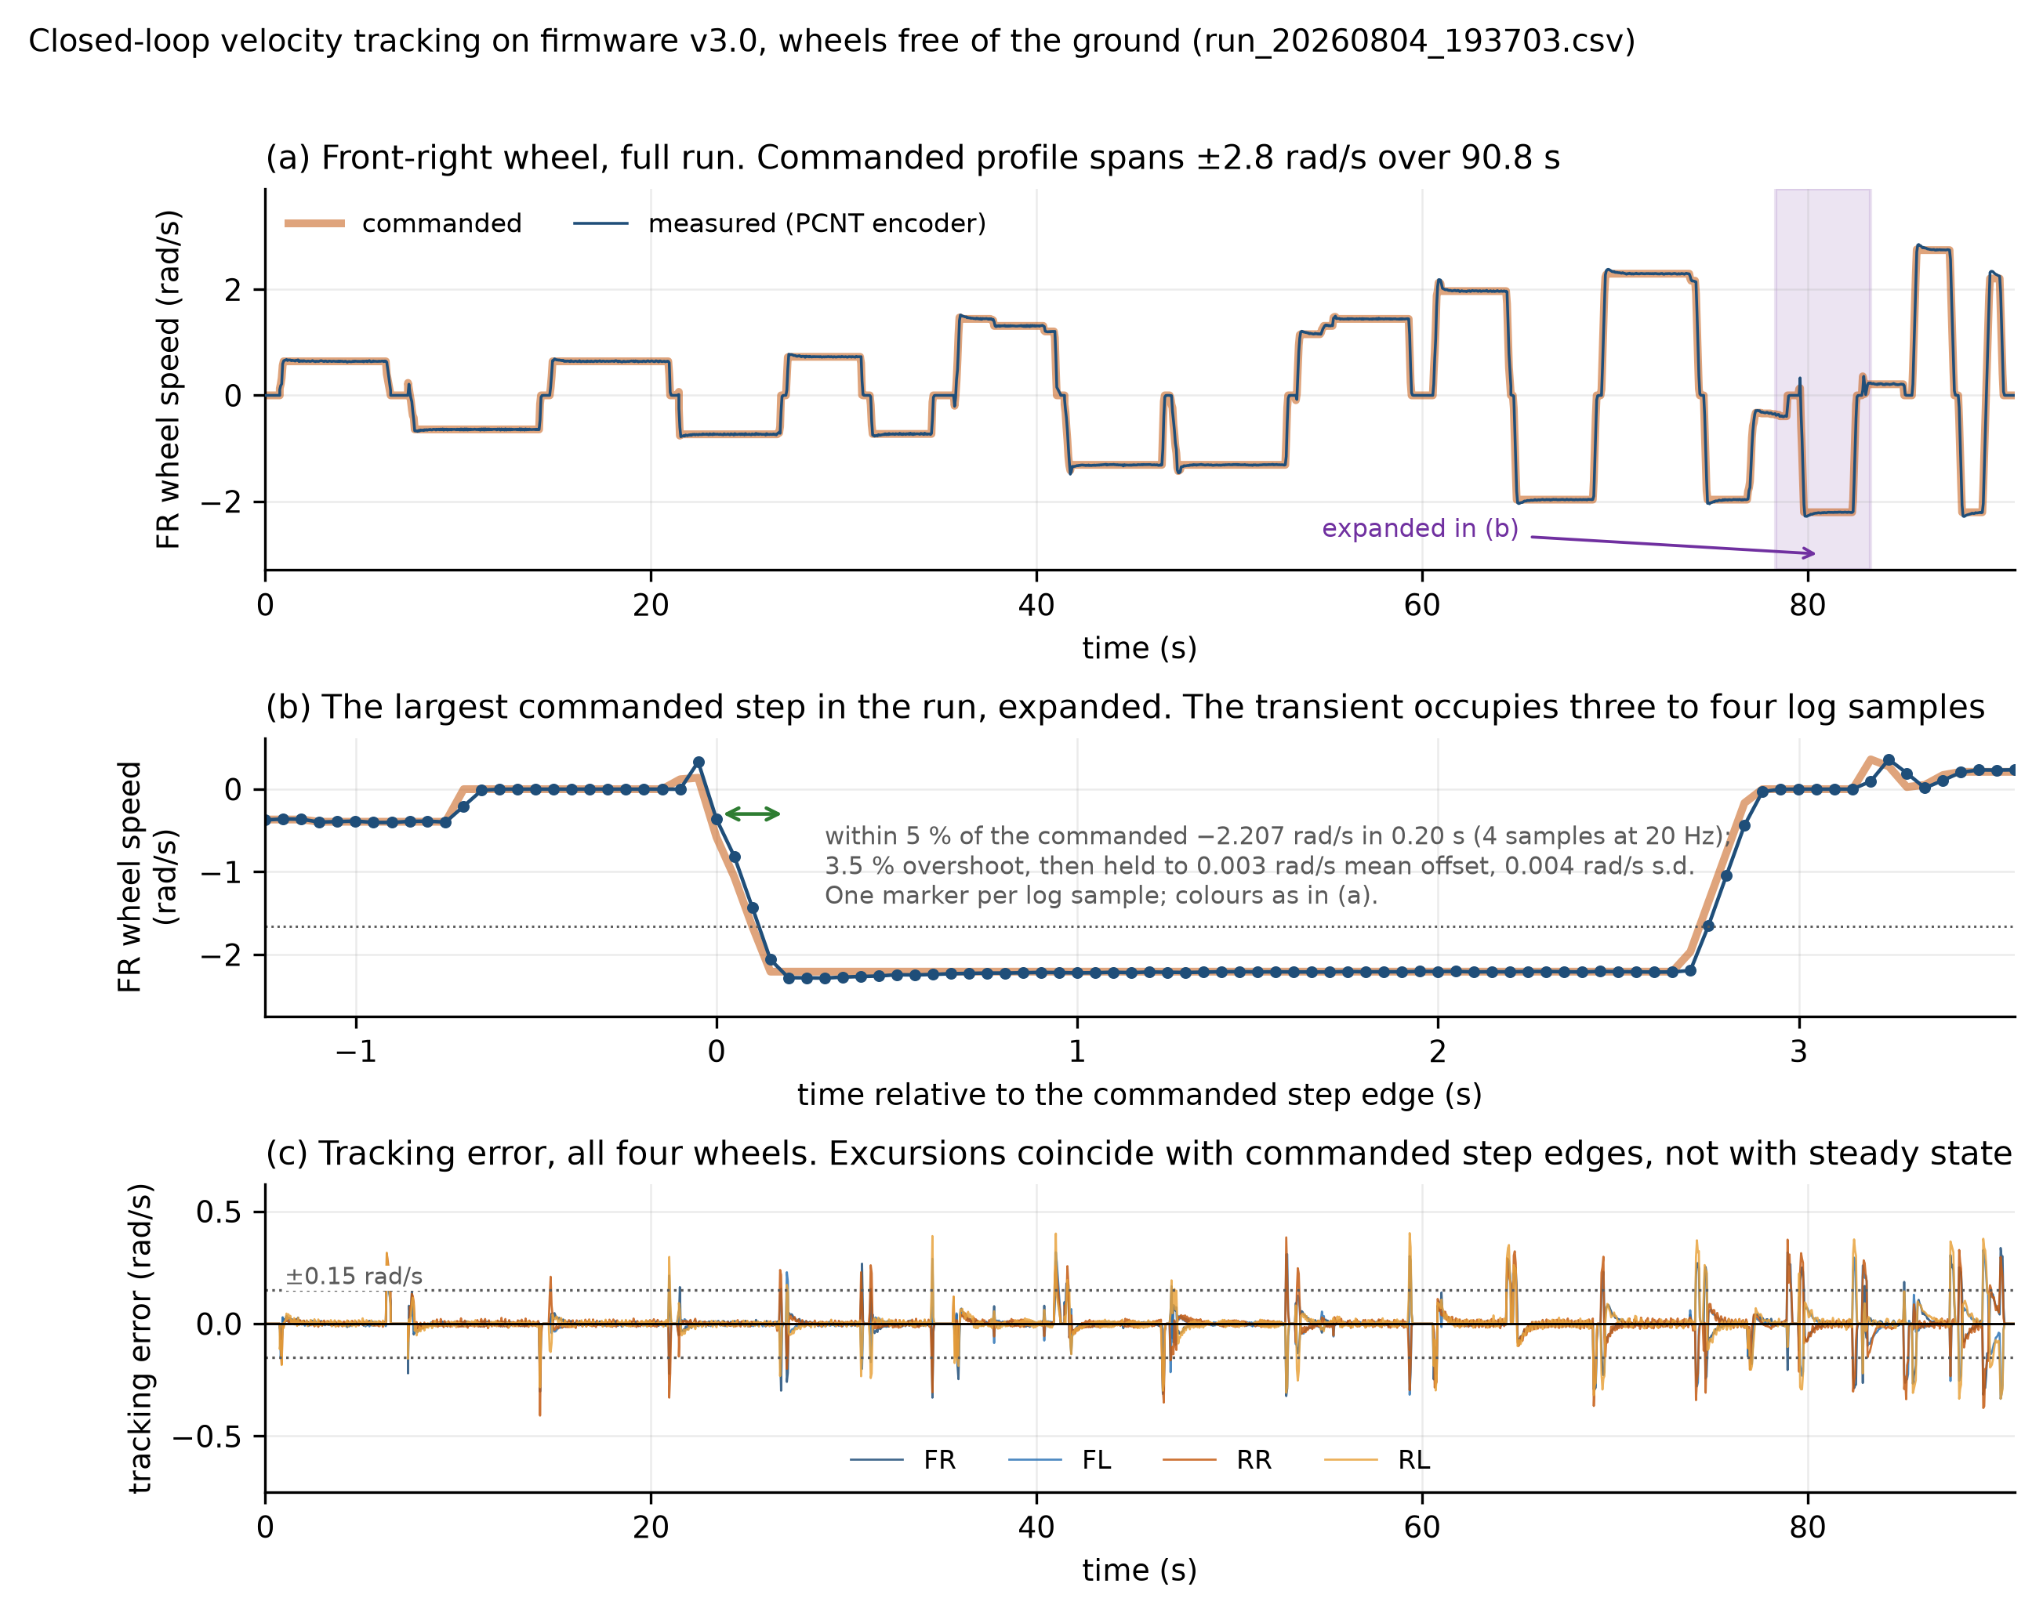
Closed-loop tracking
Figure 9. Closed-loop wheel velocity tracking, wheels free of the ground. Panel (a) is the front-right wheel over the full 90.8 s run, with the shaded band marking the region expanded in panel (b). Panel (b) expands the largest commanded step in the run, plotted against time relative to the step edge with one marker per 20 Hz log sample: the wheel reaches within 5 per cent of the commanded −2.207 rad/s in 0.20 s, overshoots by 3.5 per cent, and then holds the level to a mean offset of 0.003 rad/s. Panel (c) gives the tracking error for all four wheels, showing that the excursions coincide with commanded step edges and not with steady state. The step transient occupies three to four log samples, which is why it appears in (a) as a vertical edge.
Tracking holds on the floor under operator control as well as on the bench. The table below comes from the motor telemetry of the drive shown as Drive C in Figure 11, logged at 20 Hz over 4,713 telemetry rows.
Wheel | RMS error (rad/s) | Mean absolute error (rad/s) | Saturated samples
Front right | 0.077 | 0.039 | 0.0 %
Front left | 0.066 | 0.034 | 0.0 %
Rear right | 0.068 | 0.032 | 0.0 %
Rear left | 0.075 | 0.039 | 0.0 %

No channel saturated at any point in the drive and no feedback channel was lost, so the controller retained authority throughout.
Tracking was evaluated in two conditions, and they are reported separately because the figures differ by about half. With the wheels free of the ground, pooled over three bench runs and 26 468 wheel-samples, per-wheel root-mean-square error is 0.040 to 0.047 rad/s. Under the full chassis weight on the floor, pooled over three runs and 35 248 wheel-samples, it is 0.066 to 0.074 rad/s. The autonomous drive tabulated above falls in the same band as the loaded case, which is the band that matters operationally; the unloaded figure is reported because it separates the controller from the wheel-ground interaction rather than because it is the number the robot works at. No channel saturated in any recorded run, and the largest drive demand observed at the operating velocity limit was 131 of the 255 available, leaving about 49 per cent of the commanded range unused under the tested condition. That is headroom in the command, not a measurement of torque or traction reserve, so it bounds what the controller was asked for rather than what the drivetrain could deliver.
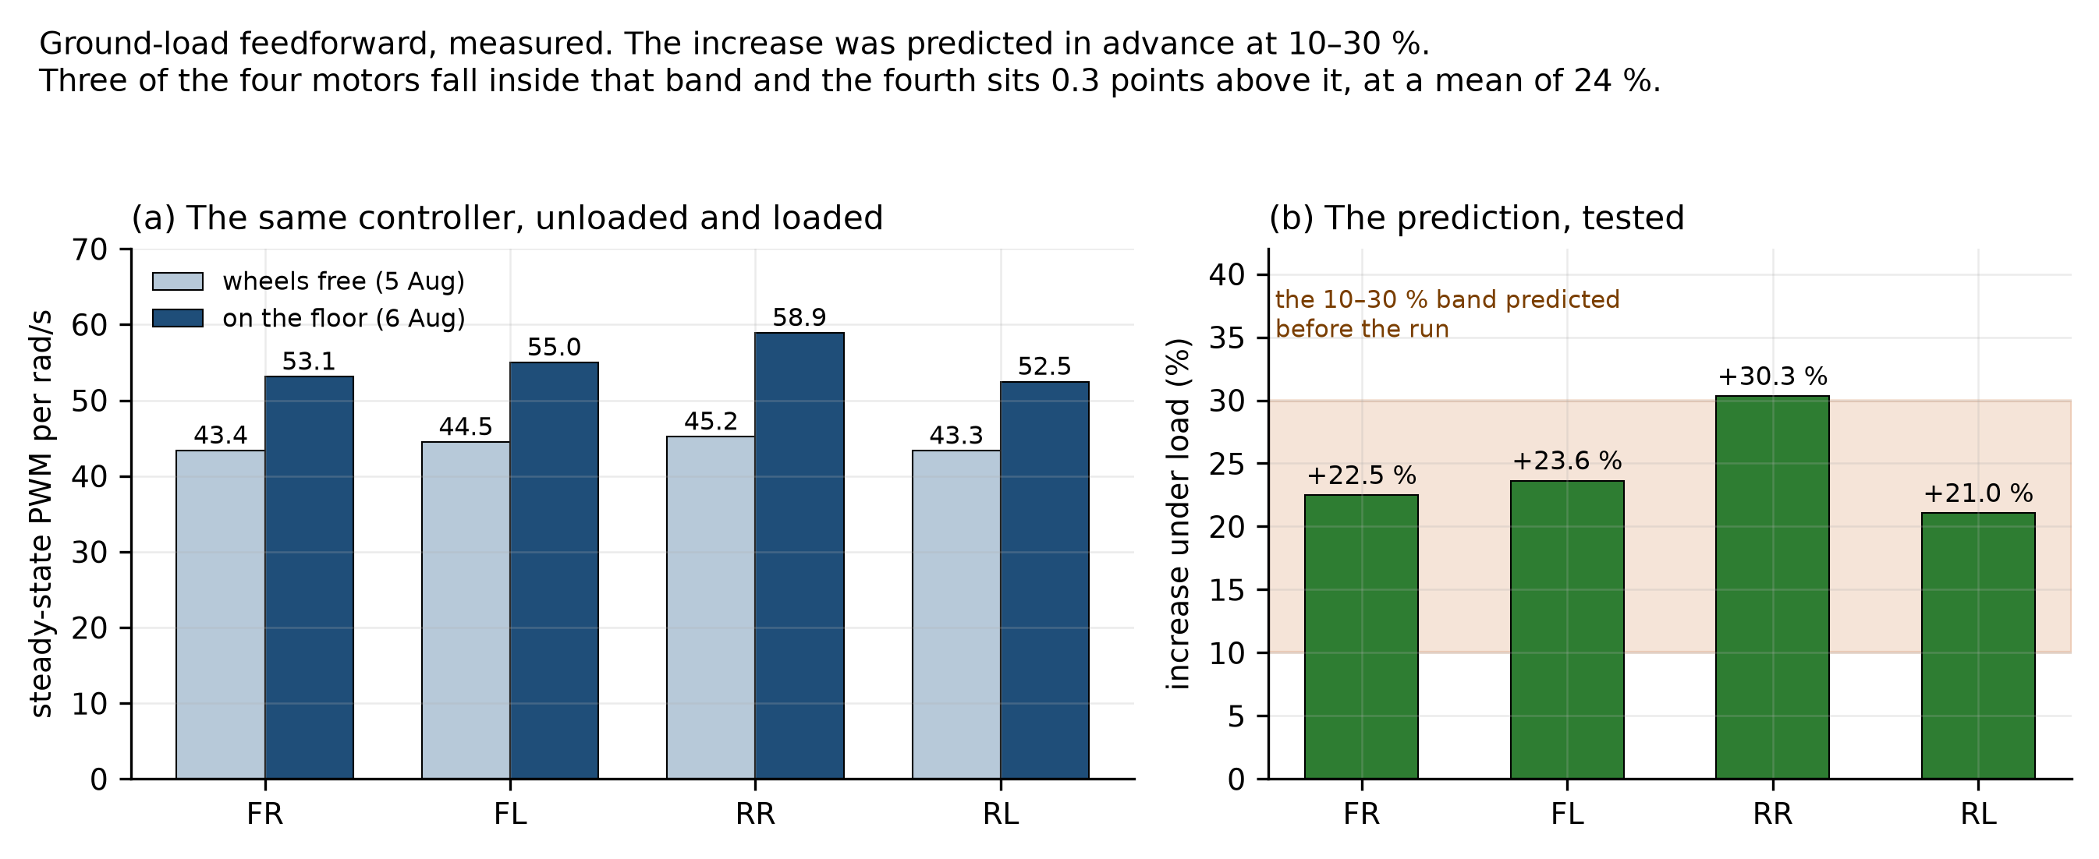
Ground load
Figure 10. Steady-state drive demand per unit wheel speed, unloaded against loaded. The increase under chassis weight was predicted to fall between 10 and 30 per cent before the measurement was made. The measured increases are 22.5, 23.6, 30.3 and 21.0 per cent, a mean of 24: three of the four motors fall inside the predicted band and the rear-right sits 0.3 points above its upper bound.
The ground-load result is stated as a prediction and a test rather than as an observation, because the predicted band was written down before the run. Moving from the unloaded condition to full chassis weight raised the feedforward demand by a mean of 24 per cent, against a band of 10 to 30 per cent set in advance. Three of the four motors fall inside that band. The rear-right reaches 30.3 per cent, which is 0.3 points above the upper bound, and it is reported as an exceedance rather than rounded into agreement. These figures come from the first of three floor runs recorded on 6 August. The two later runs of that afternoon, at the same commanded levels but driven over different patches of floor, give means of 14 and 3 per cent, so the increase is real while its size is not established to better than the width of the band it was predicted against. The likeliest reason is the surface rather than the load: casual driving covers different floor patches and headings, where a staircase test holds position and sweeps demand instead. That test has not been run on the floor, and it is what would settle the figure. The one motor sitting at the edge of the band is worth keeping in view when it is.

1.11 Results: kinematics and motion estimation
The implemented forward-kinematic transformation was checked against independently generated reference twists across twenty thousand simulated cases. The round trip reproduces them to a worst case of 2.22 × 10⁻¹⁶, which is of the order of machine epsilon for double precision, so the implementation is numerically exact to the limit of the arithmetic it runs on. What this establishes is that the transformation is coded correctly and contributes no numerical error of its own. It says nothing about the physical wheel-ground model, which is what the floor measurements below address.
The odometry integrator was checked the same way. Position was recomputed offline from the raw encoder record for a complete drive and compared against the estimate the robot published live. The two diverge by at most 0.0054 m at any point during the run and by 0.0000 m at its end. The online and offline implementations are therefore numerically consistent, which rules out a discrepancy between them as the source of the observed drift. It does not rule out an error shared by both, since they integrate the same measurements through the same model; that class of error is addressed in the floor measurements and in Section 1.13.
Endpoint closure was then measured on the floor against a tape-measured reference mark rather than against an instrumented ground truth, and the precision of that reference bounds what the numbers mean. Marking and re-reading a floor position by tape and eye is good to a few millimetres at best, so the 4.582 m route closing to 3.1 mm, nominally 0.07 per cent of path, should be read as closure at or below the resolution of the reference rather than as a 3.1 mm measurement. The 38 s square closed to 2.58 cm, which is comfortably above that floor and is a meaningful figure.
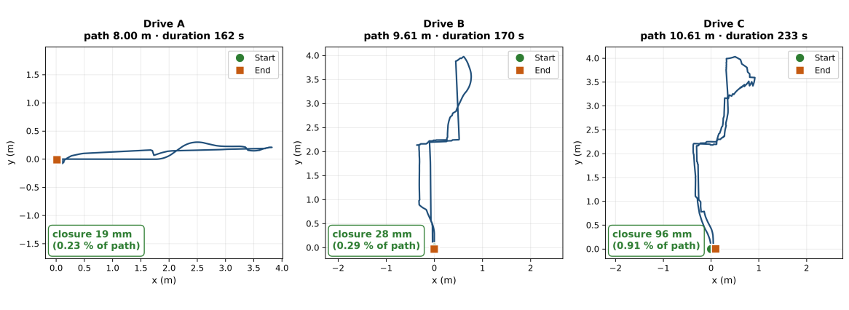
Endpoint closure
Figure 11. Wheel-odometry trajectories for three logged drives, each driven manually under operator control, plotted from the recorded pose. In each case the robot was driven back to its starting mark and the wheel-odometry estimate closed to 19 mm over 8.00 m, 28 mm over 9.61 m and 96 mm over 10.61 m, which is 0.23, 0.29 and 0.91 per cent of path travelled respectively.
Three complete drives logged in the test area are shown in Figure 11. Path lengths range from 8.00 m to 10.61 m over durations of 162 to 233 s, and each closed to within 1 per cent of the distance travelled. The longest of the three, which includes the most rotation, closes at 0.91 per cent; the two shorter routes close at 0.23 and 0.29 per cent.
The sub-1-per-cent figure should not be generalised past the route lengths it was measured on, and the project’s own longest drives are the reason. On an 18 m route the same estimator closed 0.229 m, which is 1.27 per cent, and on a second long route 0.257 m over 18.14 m, which is 1.42 per cent. The honest statement is therefore bounded: closure stays below 1 per cent of path on every route up to about 10 m, reaching roughly 0.1 per cent on short straight runs, and sits between 1.1 and 1.5 per cent on the longest routes driven. Error grows with the amount of rotation a route contains as well as with its length, which is consistent with the increased lateral roller motion expected during rotational manoeuvres. Separating the two effects calls for routes that vary length and rotation independently, which is a direct use for the larger test space.
The yaw-consistency residual of Section 1.5 was evaluated across four analysed drives, one of them a deliberately irregular trajectory rather than a clean circuit. Its median while moving is 0.035 rad/s, with a 95th percentile of 0.111 to 0.124 rad/s and a worst instantaneous value of 0.354 rad/s. No sample in any of the four drives crossed the 0.5 rad/s episode threshold, which is the default of the analysis tool rather than a value derived from the drivetrain, and was fixed before the drives were analysed rather than chosen afterwards. It sits about four times the 95th percentile observed, so it detects gross events and would not resolve a slow systematic drift. Within the sensitivity of this measure, and at the roughly one-per-cent common-mode weighting derived in Section 1.5, the asymmetric geometry is not producing the sustained wheel-fight or scrubbing that might reasonably be expected from a non-symmetric layout. The measure is blind to a slip mode in which all four wheels slip together, which is taken up in Section 1.13.

1.12 Results: perception
Two perception results are reported, and they are of different kinds. Figure 12 is a property of the machine: the mast sits in the scan plane, so the robot blocks part of its own sweep, and the sector was measured at five independent headings rather than assumed from the geometry. Figure 13 is a property of how the robot is driven rather than of what the scanner can see, and it turned out to matter more.
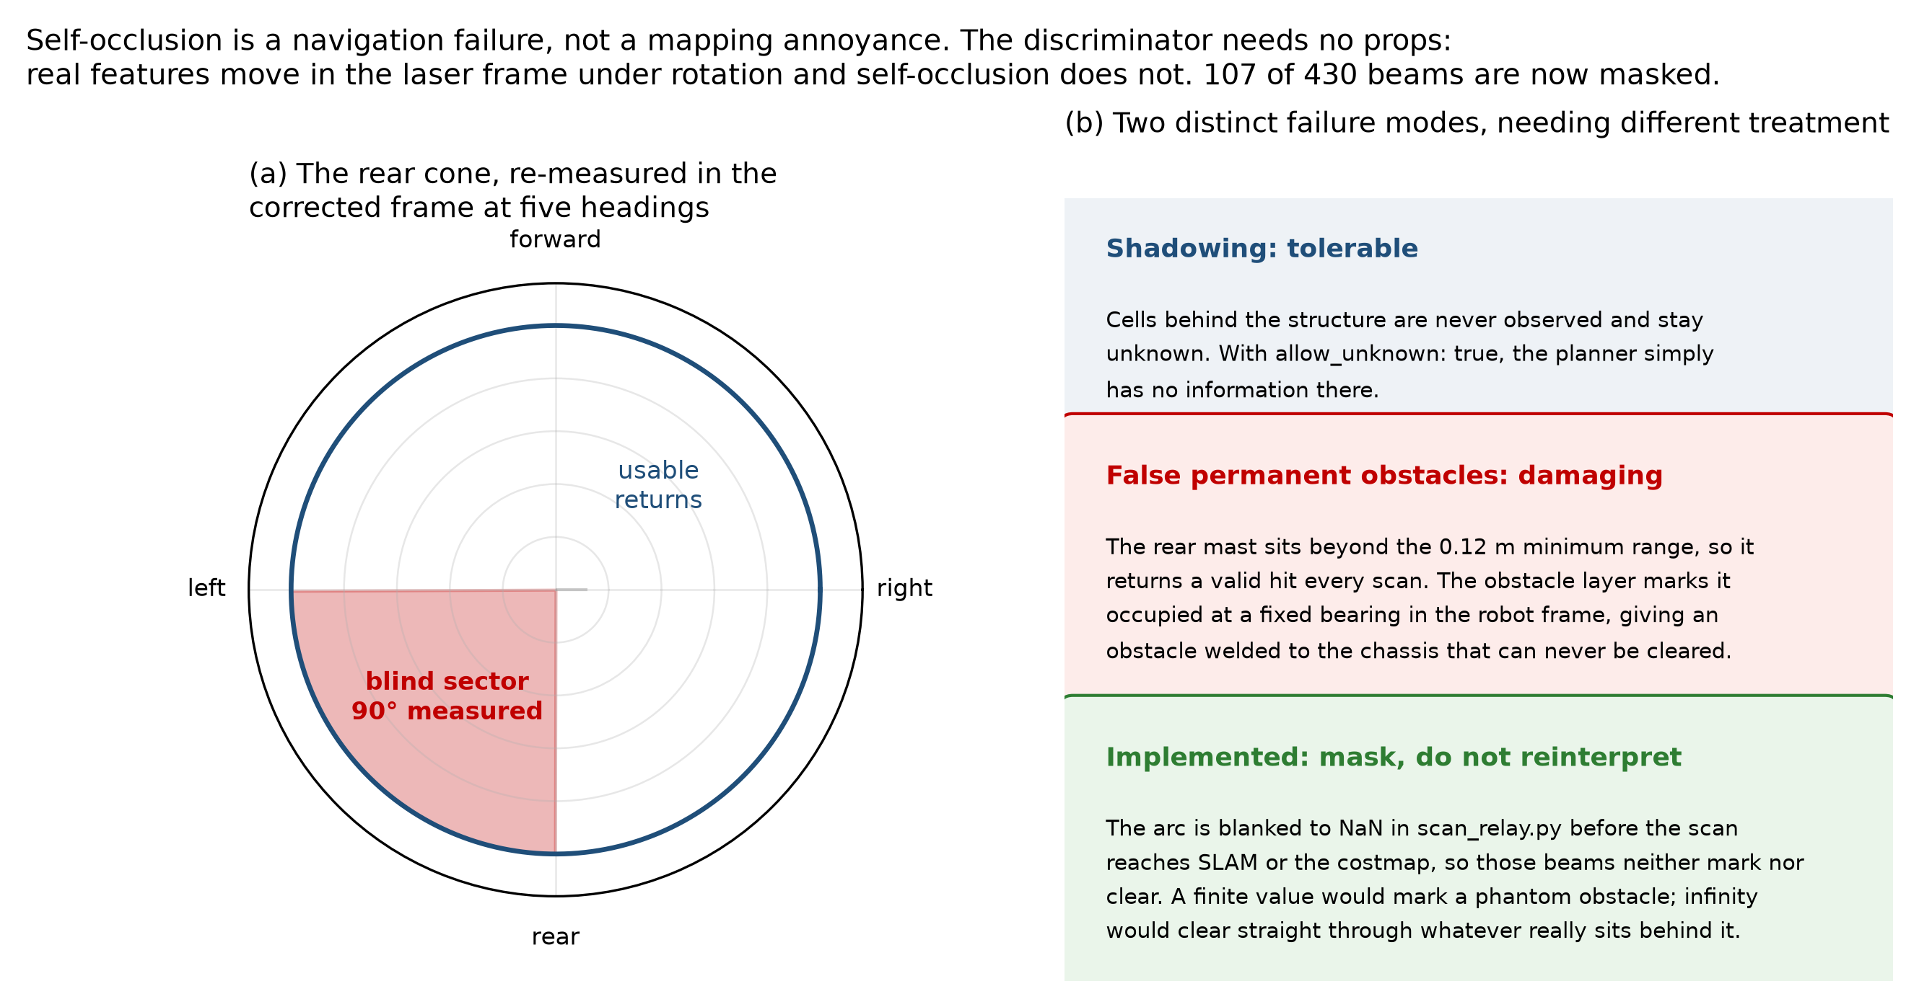
Self-occlusion
Figure 12. The self-occlusion sector, re-measured at five independent headings. The mast and payload block a wedge of approximately 90 degrees, covering 107 of the 430 beams returned per revolution. Unmasked, these returns are interpreted as an obstacle travelling with the robot.
The self-occlusion measurement is consistent across five independent headings and is now handled in software. It is stated here because it is a general consequence of carrying a payload above a single-plane scanner, and because the trade-off between sensor placement, sector masking and accepted coverage loss does not appear to be characterised quantitatively in the literature.
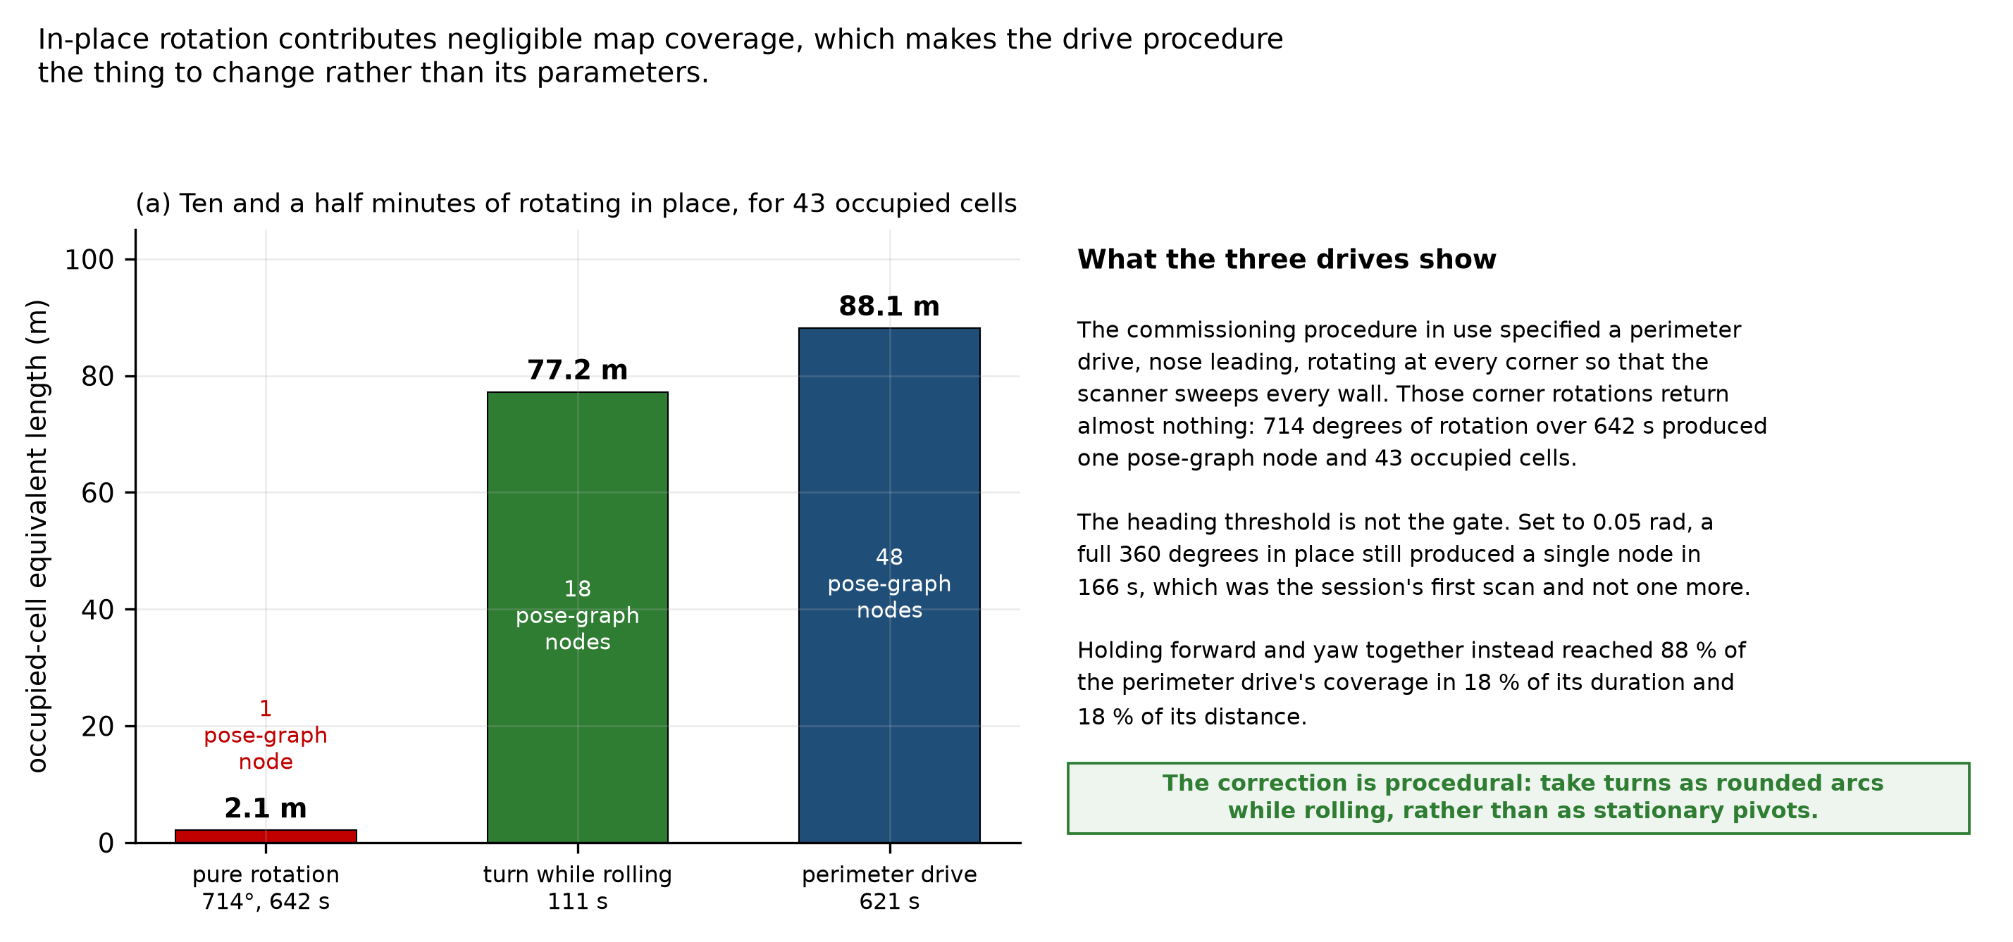
Rotation and mapping coverage
Figure 13. Map coverage accumulated under three drive patterns, measured as occupied-cell count multiplied by the 0.05 m cell size. The quantity is an occupied-cell equivalent length, a proxy for how much occupancy the map has committed to rather than a physical wall length: a single wall rendered several cells thick contributes several times its own length, so the totals exceed the perimeter of the room. Rotation in place contributes almost nothing: a deliberate 714-degree rotation over 642 s produced 43 occupied cells, 2.1 m on this measure. A 111 s arc combining rotation with translation produced 1545 cells, 77.2 m, which is 88 per cent of what a full perimeter drive accumulates in 18 per cent of its duration.
This is the most operationally consequential perception result obtained. The commissioning procedure in use had specified rotating in place at each corner to survey the space. That procedure discards its own corner observations: under the deployed mapping configuration, rotation in place contributed almost no new occupied cells, measured across three separate runs. The effect is a property of that configuration rather than of lidar in general, since the thresholds governing when a scan is integrated and when a pose-graph node is inserted are both motion-dependent, and neither was varied here. It is nonetheless the configuration the robot maps in, so the procedural consequence stands: coverage accumulates through translation, and turns must be taken as rounded arcs while rolling rather than as stationary pivots. Correcting the procedure requires no hardware modification, and it was the highest-value procedural change identified during this work.

1.13 Results: mapping, and the constraint imposed by the available workspace
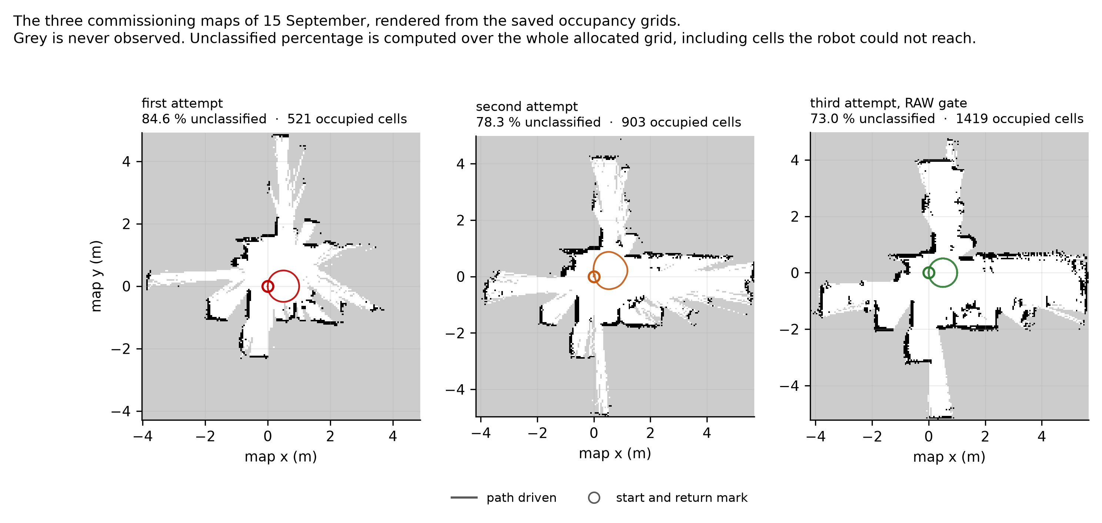
Commissioning maps
Figure 14. The three commissioning maps of 15 September, rendered from the saved occupancy grids. Within the classified regions the recovered wall geometry is consistent across all three runs and with the layout of the room, and the robot returns to its starting mark in each case. The grey regions are cells that never accumulated enough observation to be classified, and they are the criterion that fails on all three. The driven path is visible as a small loop near the origin in each panel, which is the coverage problem seen directly: the robot cannot classify what it cannot drive past.
Maps are produced repeatedly and reliably, and within the regions that accumulate enough observation to be classified, the wall geometry they recover is consistent across the three runs and with the layout of the room. Four acceptance criteria were defined for a commissioning map before the mapping work began: that the map is not folded, that doubled walls occupy less than 1 per cent of occupied cells, that unclassified cells occupy less than 50 per cent of the mapped area, and that the robot returns to its starting mark within 0.15 m. These are engineering acceptance thresholds set by this project, not values taken from the literature. The 0.15 m return figure is the one with a physical basis, being the order of clearance the target aisle geometry allows; the other three were chosen as the condition a map would have to reach before attempting localisation against it was worthwhile. They are stated here so the results below are read against a bar fixed in advance.
The three maps of Figure 14 are the commissioning attempts of 15 September, and every figure quoted here is computed from the occupancy grids they show. None of the three is folded, and return to mark passes comfortably on each, the best measured at 6.4 mm. Doubled walls measure 0.7, 0.8 and 2.9 per cent of occupied cells, so two of the three clear the 1 per cent bar and the third misses it by close to a factor of three. The spread is itself informative: the run with the best coverage is the one with the worst doubled-wall figure, because it was driven with the loosest lidar quality gate. Tightening that gate did reduce doubled walls, to 1.1 and 0.9 per cent, but it tore the free space into disconnected regions and the map was graded folded, so the looser gate was retained on the grounds that a connected map with thicker walls is more useful than a clean one that has come apart.
The fourth criterion, coverage, is the one the available test area governs directly. Unclassified cells occupy 73.0, 78.3 and 84.6 per cent of the mapped area against a threshold of 50. Coverage accumulates through translation past surfaces, and the circuit available here is a few metres of it, much of the boundary furniture rather than continuous wall. The robot classifies what it drives past, so the figure is a statement about the space rather than about the mapping layer.
The denominator matters and is stated here because it qualifies the figure. The percentage is computed over every cell in the published occupancy grid, which is the bounding extent the mapper has allocated rather than the traversable floor area. Cells the robot could never reach or see are counted in the denominator, so the figure is sensitive to how large a window the mapper happens to allocate and overstates the fraction of reachable space left unobserved. It is used here because it is the criterion that was written down before the mapping work began and because the same definition applies to every run compared, which makes the run-to-run comparison valid even where the absolute number is soft. A coverage criterion computed over a fixed region of interest corresponding to the traversable area would be the better measure and is owed.
Coverage is the criterion that fails on all three runs, and the dominant limiting mechanism is consistent with the coverage dependence measured in Section 1.12 and with the restricted geometry of the available test area. Coverage accumulates through translation past surfaces, at a rate set by how much distance the robot can travel while observing new geometry. The laboratory area available for this work permits a traversable circuit of only a few metres, much of it bounded by furniture rather than by continuous wall. A drive confined to that circuit cannot accumulate the observation the coverage criterion requires, however well the platform performs, because the criterion is a statement about how much of the mapped area has been seen and the robot cannot see what it cannot drive past.
What follows is concrete in kind if not yet in magnitude. Validating the mapping and localisation layers requires a test space offering a continuous traversable loop with unobstructed wall on at least one side and aisle widths representative of the target application. An initial target of fifteen to twenty metres of path is proposed on the grounds that it is several times the few metres currently available, not derived from a measured coverage-accumulation rate; establishing that rate, and with it the path length a 50 per cent coverage criterion actually demands, is itself one of the first measurements the new space would support. Securing such a space is the principal practical prerequisite for the next stage of the work, and it is the reason the localisation mode that depends on a saved map has not yet been exercised.
Two further findings from the mapping work changed a design decision, and both are given with their evidence.
Scan matching was measured against wheel odometry rather than assumed better. Scan matching is the mechanism by which lidar precision is meant to reach the pose estimate. Here it increased pose error instead of reducing it. The comparison was made twice, at two scales, with the robot physically returned to a marked start point and the closure measured against that mark.
Route | Range cap | Wheel odometry alone | With the scan-matching front end
38 s square, 1.42 m of path | 10 m | 2.58 cm | 6.2 cm
1047 s drive, 21.85 m of wheel path | 10 m | 0.229 m, 10.53° | 0.477 m, 16.18°
82.5 s circle, 3.193 m of path | 5 m | 16.2 mm, 0.51 % | 206.7 mm, 6.47 %

On the 21.85 m route the front end applied 11.08 m of cumulative correction and roughly doubled the error, by a factor of 2.09 on position and 1.54 on heading. Nineteen loop closures fired during that drive, so the result is not an artefact of a back end that never ran.
The third row is the most tightly controlled of the three and was run last, specifically to test the objection that every earlier measurement had been taken with the range cap at 10 m or more. The cap was reduced to 5 m and verified against the live node before the drive. Both estimates in that row come from the same 3.193 m of driving, the same wheels and the same scans, with the robot physically returned to its mark, so the run carries its own control: the matching-on drive’s own wheel odometry closed at 16.2 mm, which is healthy, and the matched estimate on that same data closed at 206.7 mm. The cap did not rescue the matcher. Four revert criteria had been written down before the drive and three fired; of five keep criteria, the only one met was the one predicted to be neutral.
The mechanism is the part worth reporting. All seventeen corrections in that run fired at a mean odometry spacing of 0.183 m with about a centimetre of spread across the whole drive. They track the creation of pose-graph nodes, not disagreement between scans, and the smallest correction in the run was 106.7 mm against a deployed search half-width of 150 mm. A front end correcting on a metronome is not responding to evidence. That also explains the zero loop closures on a route that returns to its own start, since a closure would arrive off-cadence and none did.
The finding is bounded to what was tested: this scanner, this front-end configuration, and three routes of which two are tight circuits that are poor geometry for matching. The project’s own notes flag circle geometry as degenerate for a matcher, because a circle shows the same walls from continuously rotating vantage points, so the third row cannot separate a matcher that fails on this robot from one that fails on circles. A one-variable comparison on the 12.04 m perimeter route, against an existing matching-off baseline on identical geometry, is still owed. Stating the result as a property of scan matching in general would go past the evidence.
Photogrammetry separated two error classes that had been treated as one. Heading at the end of a drive was measured from video against world-static floor features, using tile-grout orientation as the reference, since the alignment criterion used throughout this work is the chassis edge parallel to the tile line. Frames were extracted with ffmpeg, position taken from a threshold centroid on floor brackets, and heading from a gradient-orientation histogram on the grout lines. The instrument was validated before its output was believed, on frames where the commanded rotation was known: it returned −27.07° against a commanded −28.0°, and −18.50° against −19.4°, agreeing within one degree in both cases. That agreement is the only uncertainty estimate available for the method, so its resolution is taken as of order one degree, which is what makes the 3.85° and 4.49° results below interpretable: they are several times the instrument’s demonstrated agreement, not comparable to it. Two failure modes were found and corrected during that validation, the first of them measuring the robot against a camera mounted on the robot’s own mast, which by construction reports no rotation at all.
On two structurally different routes, wheel odometry, the published estimate and the SLAM pose all reported 3.85° and 4.49° of heading change by the end of the drive, while the floor, read photogrammetrically against the tile grout, put the robot within 0.03° of the heading it started from. The robot came back to its heading. The estimators did not. Three estimates agreeing with one another while all three disagree with the floor is the signature of an error they share, not one that separates them.
What that narrows the error to should be stated carefully, because the obvious reading is stronger than the evidence. The yaw-consistency residual rules out significant differential slip between wheels, and the offline re-integration rules out an integration fault. The two leading candidates that remain are an encoder or wheel-radius scale error, which is estimator error and is recoverable by calibration, and a slip mode in which all four wheels slip together and the platform’s motion stays rigid, which is physical and is not. The elimination is not exhaustive: a geometric parameter error, a systematic mounting offset or a timing error between the encoder and pose streams would produce a similar signature and have not been separately excluded. No instrument currently fitted to the robot can distinguish any of them. That is the specific reason an independent heading reference is the next measurement rather than a general improvement, and it is taken up in Section 1.15.

1.14 Results: autonomous navigation
Autonomous point-to-point navigation has been demonstrated on the platform within a live mapping session. The demonstration is preliminary and the number of trials is small, so it is reported as what it is rather than as a validated capability. The first complete autonomous round trip was performed in August: the robot drove out, reversed its heading and returned, holding direction to within 5.5 and 3.7 degrees on the two legs and stopping 4.6 cm short of the commanded stop point. In later trials goals were selected by tapping the map in the dashboard and the platform reached them in 21 and 26 s respectively. Three goals were commanded across three trials and all three were reached. Establishing a success rate, a stopping-error distribution and behaviour against obstacles requires a larger trial count in a space that permits varied routes, which places this alongside the mapping work behind the same test-space constraint.
The operator interface was verified geometrically rather than by eye. The transformation from a tapped screen pixel to a world coordinate was tested across the full round trip against its analytic value at three different display pixel densities, and agrees to within one part in a million, which over the extent of the test map is well under a millimetre. This is a check that the transformation is coded correctly, not a statement about pointing accuracy, which is set by the size of a fingertip against the map scale and was not measured.
Navigation currently operates within a live mapping session rather than against a previously saved map, for the reason given in Section 1.13.

1.15 Operating without an inertial sensor
The platform carries no inertial measurement unit. That was a decision rather than an omission, and it is worth setting out, because it is the first question the estimator results invite.
Objective 2 asks for a pose estimate characterised against an independently measured physical reference, with a stated drift figure over a stated distance and an explicit account of which sensors are required to reach it. The third clause is the research content, and it is a question about sensors rather than a requirement to own one. Fitting inertial measurement at the start would have removed the ability to answer it. Fusion improves the estimate; without a characterised unfused baseline at the operating scale there is no way to say by how much, or which error it removed. The unfused platform is that baseline.
Which instrument binds the error at the 5 m operating scale is not something this year’s data settles, and the report does not claim it does. Endpoint closure was not measured at 5 m: the routes driven were either short and straight, closing to roughly 0.1 per cent, or long and rotation-heavy, closing at 1.1 to 1.5 per cent, and applying either rate to an intermediate distance is extrapolation rather than measurement. The scanner is characterised on its own terms instead. Its stationary ray scatter is 22.3 mm in the 1.5 to 2.0 m band in one 60 s capture and 31.9 mm in a second capture taken from a differently obstructed position, the latter failing the 25 mm half-cell criterion the mapping configuration implies. Beyond 2.5 m neither capture agrees with the other. What that establishes is that the scanner is unreliable at the ranges a corridor-width map depends on, not that it is the larger of two quantified error terms. Both estimators have limitations at the intended scale, and separating their contributions needs the third measurement an inertial sensor would provide.
What an inertial sensor would add is specific, and the measurement of Section 1.13 gives it a target. Heading errors of 3.85° and 4.49° were invisible to every instrument on the robot, because all of them derive from the same wheel measurements. A rate gyroscope measures angular rate independently of the wheels; integrating it gives a heading estimate that drifts with bias but that does not share the wheel-derived error, and that is what would make this class of error observable and separate an encoder scale error from a rigid all-wheel slip mode. That is the falsifiable test, and it can only be run against a baseline that already exists.
What is not claimed is that the platform is better off without one. Fusion would reduce heading error, an inertial sensor is the right next purchase, and nothing here argues otherwise. The claim is about order of work. Objective 2 therefore closes as characterised rather than as optimal, and inertial measurement with fused state estimation is the first item of Chapter 4, now carrying a specific number to be tested against rather than a general expectation.

1.16 Present state of the platform
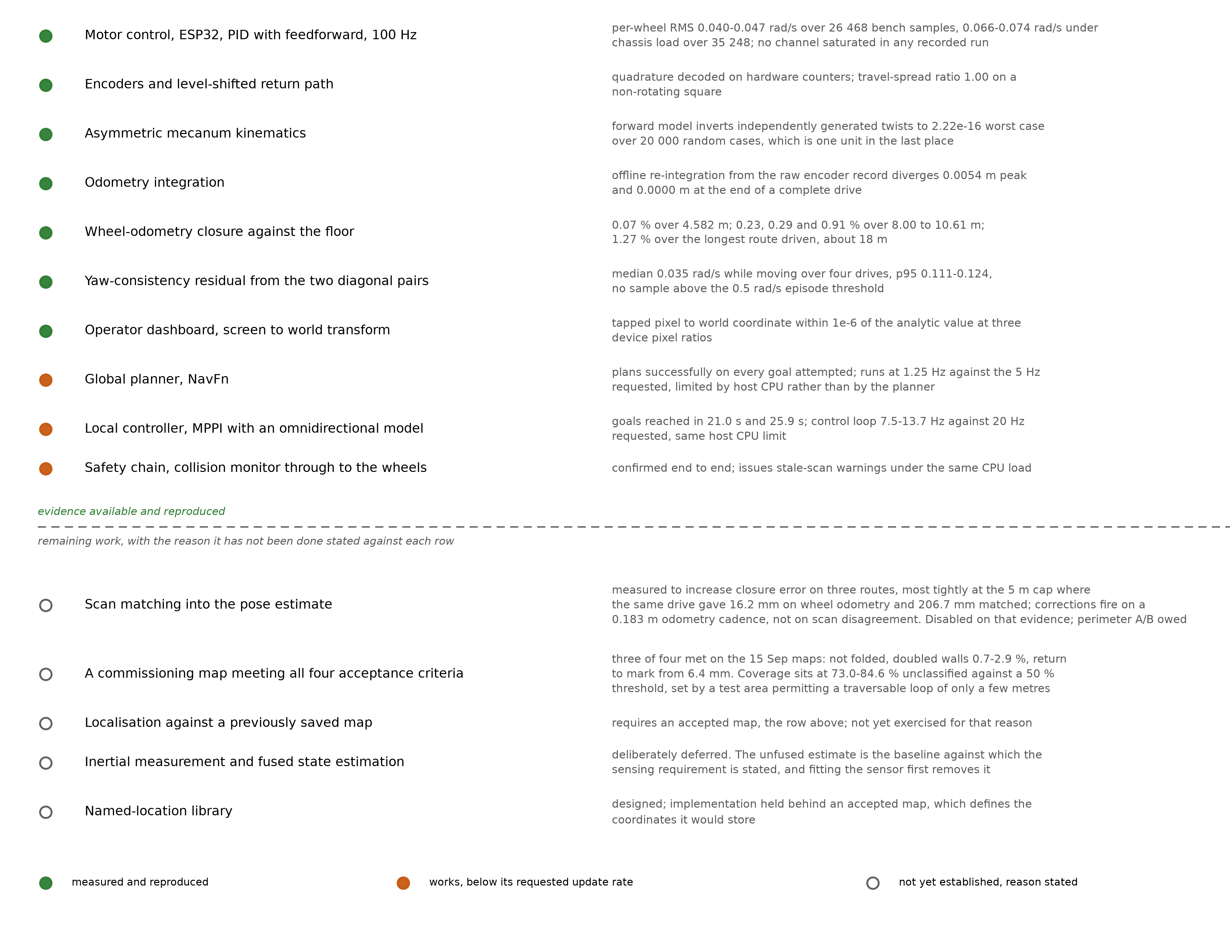
System validation status
Figure 15. Evidence status of each layer of the system, with the measurement given beside each entry. The evidence is not all of one kind: closure against the floor is an external reference, the kinematics and odometry rows are checks against an independent implementation, and the planner, controller and safety rows are operational demonstrations rather than measurements against a reference. Three components work but run below their requested update rates. For the five layers that are not yet established, the entry states the specific reason rather than recording a failure; in three of those five the reason is the size of the available test area rather than anything on the platform.
The layers below the map are measured and working: the motors track, the encoders are clean, the kinematic and odometry implementations are numerically consistent to machine precision across the cases tested, the frame composition reproduces to four decimal places, the planner plans, the local controller reaches goals, and the operator interface is geometrically correct. Wheel odometry, which is the least expensive sensing on the platform, is currently its most extensively characterised source of state estimation.
Figure 15 states the evidence against every layer, and what it shows is that the work still open resolves to two constraints rather than to a list of separate shortfalls.
The first is the size of the available test area. Coverage accumulates through translation past surfaces, at a rate set by how far the robot can drive while observing new geometry, and the laboratory available for this work permits a traversable circuit of only a few metres. That single limit propagates: it holds the coverage criterion below its threshold, which withholds an accepted commissioning map, which in turn leaves localisation against a saved map unexercised and gives the named-location library no coordinates to store. Four entries in Figure 15, and one cause. No further work on the platform moves any of them, and a test space offering a continuous traversable loop lifts all four together.
The second is the deliberate absence of inertial measurement, for the reason set out in Section 1.15. Working without it is what made the unfused baseline measurable, and the cost is one specific error class that stays unobservable to a wheel-only instrument set. Adding the sensor is the first item of Chapter 4 and it now has a measured target to be tested against.
Three further components, the global planner, the local controller and the safety chain, work correctly but run below their requested update rates because of the processing available on the host computer. That is a property of the computer rather than of the software, and a faster host raises all three.
Scan matching is the one entry that is switched off by choice rather than by constraint, on the measurement reported in Section 1.13.

1.17 Conclusions on the robot
The asymmetric geometry survives the move to full scale. That is the headline, and it is worth stating in the form the evidence supports rather than in the form the project would prefer: no asymmetry-specific penalty has been detected in any experiment performed. The transformation is implemented correctly to the limit of double precision, tracking is clean on every axis including the lateral and rotational ones, endpoint closure holds below 1 per cent of path out to 10.61 m, and no yaw-consistency residual above the episode threshold has appeared. An absence of penalty across a year of measurement is not the same thing as a measured cost of zero, and Objective 3 is not closed until a matched symmetric baseline exists to compare against.
Below the map, the platform is characterised. The motors track to a known error in both the unloaded and loaded conditions, the encoder path is clean after the level-translation work of Section 1.4, the feedforward is fitted rather than guessed, and the kinematic and odometry implementations have been checked against an independent reference rather than against themselves. At and above the map, three layers are not established, and in each case the reason is specific. Mapping produces consistent and repeatable geometry but cannot meet a coverage criterion in a room this size. Localisation against a saved map has never been run, because there is no accepted map to run it against. And a scan-matching front end, measured rather than assumed, made the pose estimate worse on all three routes it was tested on, so it is switched off.
The two constraints those shortfalls resolve to are worth separating, because only one of them is about the robot. The first is the size of the available test area, which is an environmental constraint and the binding one. The second is the deliberate absence of an inertial sensor, which is a decision rather than an omission, and which is what made the unfused behaviour of the wheel estimate visible in the first place. Both are addressed directly in Chapter 4.

Chapter 2 Environmental Monitoring for the Warehouse Space

2.1 Motivation
The second strand of this work concerns the environment inside the warehouse rather than motion through it. Stored goods and the people handling them are both sensitive to air condition. Reviews of post-harvest practice for perishable produce identify storage temperature and relative humidity as the principal levers on quality loss and shelf life, alongside controlled-atmosphere techniques that adjust the surrounding gas composition [27]. Carbon dioxide concentration is a long-established surrogate for ventilation adequacy rather than a direct measurement of it, since indoor concentration rises with occupant respiration and falls with air exchange, and it is used as such in indoor air quality assessment [28]. Particulate load affects both product quality and worker health. In Indian conditions these quantities frequently sit outside the range in which either people or goods do well.
Two considerations motivated this strand. First, environmental variables relevant to storage conditions and worker exposure are measurable but are not necessarily incorporated into the control of air-treatment systems. Second, timer-based operation of treatment equipment provides no feedback from the condition of the air being treated. Such open-loop operation cannot adapt treatment to changing environmental conditions or indicate whether treatment is required. These considerations motivated the development of a closed-loop monitoring and control system in which environmental measurements inform both actuation and operator awareness.
There is a narrower version of the same argument, and it is the one the system was actually built against. Continuous monitoring in a laboratory or a store room is usually done one of two ways: with proprietary instruments that are expensive and will not be told what to do, or by somebody writing readings down, which introduces transcription error and leaves a gap whenever nobody is there. An air-treatment appliance adds a second requirement on top of that. It has to act on what it measures, and somebody has to be able to confirm that the action had an effect. A treatment duct running on a timer offers neither. It cannot raise airflow when the air is dirty, and it cannot tell anyone when its lamp has failed.
The system reported here was designed, built and deployed for this purpose. It instruments an air treatment unit with continuous multi-parameter sensing, drives the lamp and the airflow from those measurements, and reports over several independent wireless channels operating concurrently, so that failure of any one communications path does not interrupt telemetry. The redundancy is in the reporting paths, not in the sensing node or its power, both of which remain single points of failure. The same architecture is intended to transfer to cold storage, to controlled-atmosphere rooms used for produce ripening, and to general warehouse environmental monitoring, which is the direction in which this strand of the work is intended to develop.

2.2 Review of Literature
Environmental sensing in storage and industrial settings. Multi-parameter environmental monitoring is well established. Low-cost non-dispersive infrared sensors give carbon dioxide measurement stable enough for indoor assessment, and an evaluation of several current parts over several months found good agreement between them despite differences in construction, factory calibration and price [29]. Optical particle counters give particulate mass concentration, and combined temperature and humidity parts are inexpensive and adequate. Non-selective metal-oxide gas sensors are cheaper still but respond to a mixture of reducing gases rather than to any one species, which is why the index they produce is treated in this work as a relative signal rather than a concentration. The engineering difficulty is rarely the individual sensor. It lies in integration, in calibration, in keeping a deployed system reporting reliably without attention, and in ensuring that the quantity driving a control decision is the quantity that actually matters.
Communication architecture. Facility monitoring systems typically choose between local wireless networking, long-range low-power radio, and cellular connectivity, and typically arrange them as a failover chain. A failover design must detect failure before it can switch, and detection is the first thing to fail in a dead network. Running independent channels concurrently avoids that dependency at a bandwidth cost that a low-rate telemetry system can absorb.
Local processing against cloud dependency. Cloud-hosted monitoring is convenient and is the common commercial pattern, but it makes continuity of monitoring dependent on external connectivity. For a facility where the monitored condition matters most during a disruption, that dependency is misplaced. A locally hosted data platform removes it.

2.3 The unit, the enclosure and the sensors
The system instruments a closed air-treatment chamber. Air is drawn through an aluminium duct by a fan set into its end face, passes a germicidal lamp, and leaves at the other end. The sensing and control enclosure is mounted on top of the duct near one end, so the electronics sit outside the treated path and the only things inside it are the lamp and the airflow. Figure 16 shows the integrated unit and the node.
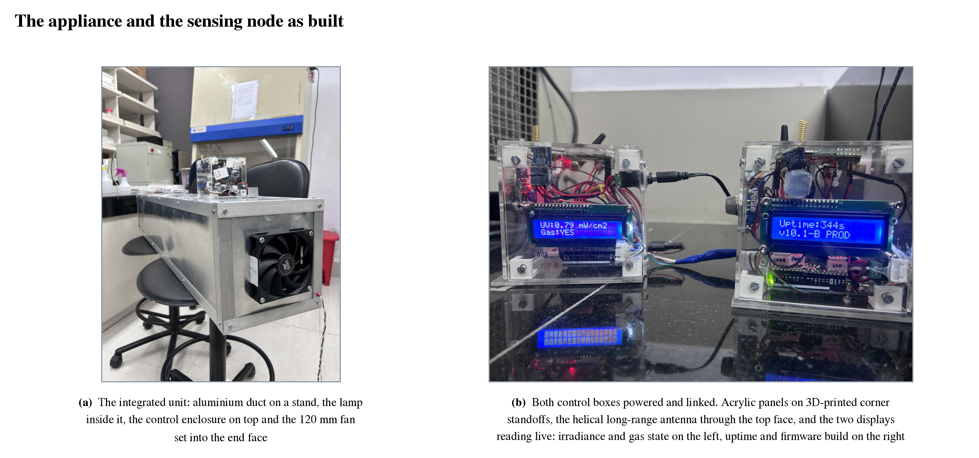
The appliance and the sensing node
Figure 16. The appliance and the sensing node as built. Panel (a) is the integrated unit: an aluminium duct on a stand with the germicidal lamp inside it, the control enclosure mounted on top near one end, and the 120 mm fan set into the end face. Panel (b) is both control boxes powered and linked. The enclosure is acrylic, each face a separate panel held on 3D-printed corner standoffs, with the helical long-range antenna through the top face and the cellular whip on a bulkhead connector at the side. The two displays are reading live, which is how a node is checked without a laptop: irradiance and gas state on the left, uptime and firmware build on the right.
The enclosure is worth a sentence because it was designed rather than bought. It is acrylic, with each face a separate panel held by 3D-printed corner standoffs and slotted machine screws, so any one face can come off without disturbing the others. The helical long-range antenna passes through the top panel and the cellular whip mounts externally on a side panel through a bulkhead connector. Two barrel jacks and a single cable egress complete the penetrations, and two runs leave through that egress: switched mains to the lamp, and the four-conductor fan line carrying supply, ground, speed command and tachometer return. One correction worth recording, because earlier project documents have it wrong and a drawing traced from those documents would be wrong too: the enclosure is not a cube. The photographs show a box visibly wider than it is deep.
Five sensing devices and two actuators sit on one microcontroller. Carbon dioxide, temperature and relative humidity come from a single photoacoustic part, which gives all three from one device and one calibration. Particulate mass at two size fractions comes from an optical counter on the same serial bus. A metal-oxide sensor supplies a general reducing-gas index on an analogue channel, with a separate digital line that trips at a hardware threshold, and an ultraviolet photodiode on a second analogue channel reads irradiance in the duct. A character display on the same serial bus cycles through eight status screens, which is how a node is checked in the laboratory without attaching a computer to it. The table below lists the parts.
The two actuators are driven differently and for different reasons. The lamp runs from mains and is switched through an opto-isolated relay, so there is no electrical path between the mains side and the logic. The fan is a four-wire part driven by a pulse-width command with its tachometer line read back, which makes it the one actuator in the system whose response can be confirmed rather than assumed. Power is deliberately split into two isolated supplies brought to a single common ground point, and that split is not an elegance. The cellular modem draws roughly 2 A in transmit bursts, and sharing a rail with the microcontroller produced brownout resets that looked exactly like firmware crashes. Any rebuild that merges the rails will reproduce that fault.
One measurement channel does not do what the system design assumes, and it is recorded here rather than left for a reader to discover. Ultraviolet irradiance is reported in milliwatts per square centimetre, but the responsivity coefficient that would convert the photodiode voltage into that unit is still set to one. The number is a voltage with a unit written after it. The sensor is fitted, it reads, and its value reaches the display and both telemetry payloads, but it appears in no control path and no alert path, which means the loop described in some project documents as taking two inputs in fact takes one. Correcting it needs a reference radiometer and a fixed measurement geometry, neither of which is difficult, and it is listed in Chapter 4.
Item | Specification
Sensing node | Arduino UNO R4 WiFi, Renesas RA4M1 core
Carbon dioxide, temperature, humidity | Sensirion SCD40 on the serial bus, 400 to 5000 ppm
Particulate matter | MPM10-AS optical counter on the same bus, PM2.5 and PM10
Gas | MQ-135 metal-oxide module, an index of 0 to 500 on an analogue channel with a separate digital threshold flag
Ultraviolet irradiance | GUVA-S12SD photodiode, 240 to 370 nm, on a second analogue channel
Local display | LCD1602 over the serial bus, eight rotating status screens
Actuators | Opto-isolated relay switching the lamp mains, and a 120 mm four-wire fan with tachometer feedback
Radios on the node | Wi-Fi, a RYLR998 long-range module, and a Quectel EC200U cellular modem
Gateway | A second microcontroller carrying another RYLR998, level-translated into the server’s serial port
Server | Raspberry Pi 5 running a message broker, a flow engine, a time-series database, a dashboard server and a control service in containers, with the radio ingestion service alongside them
Channels | Wi-Fi every 5 s, long-range radio every 30 s at no more than 240 bytes, cellular messaging on alert and every 30 min
Control law | Lamp on above a gas index of 200 and off below 150; fan ramped from half to full command across an index of 200 to 500
Alert thresholds | 38 °C, 1200 ppm carbon dioxide, gas index 200, 55 µg/m³ PM2.5
Power | Two isolated 12 V supplies brought to a single common ground point
Zones | Four, across two radio-isolated deployments against one database

2.4 The communication architecture
Telemetry leaves the node by three routes at once. Local Wi-Fi carries a full message every five seconds to a broker on the server, where a flow engine ingests it and writes it to the time-series database. A long-range radio sends an abbreviated packet of at most 240 bytes every thirty seconds to a second microcontroller acting as a gateway, and a dedicated service on the server reads that gateway over a serial link and writes to the same database with the same schema, distinguished only by a source tag. A cellular modem sends a short message on any threshold breach, on the corresponding clear, and as a summary every thirty minutes. Figure 17 traces all three.
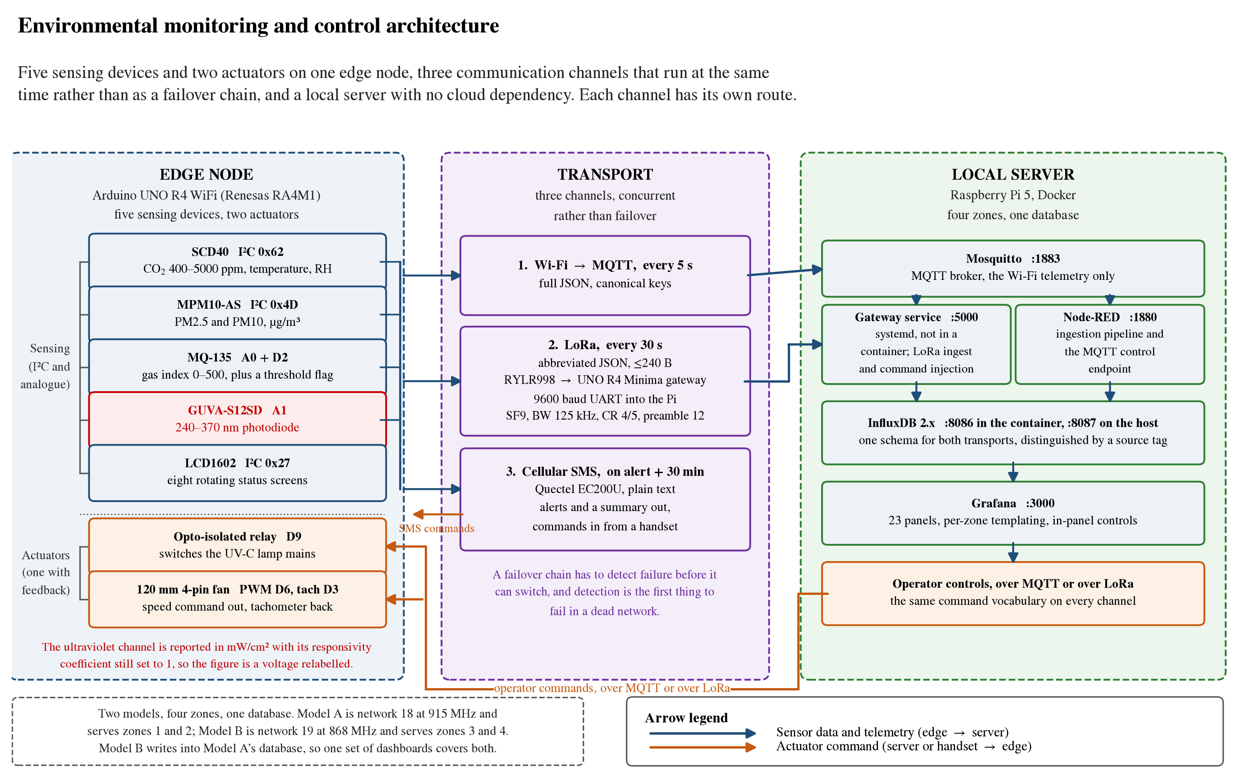
Monitoring and control architecture
Figure 17. The monitoring architecture end to end. Five sensing devices and two actuators sit on one microcontroller; three communication channels run at the same time rather than as a failover chain; and a containerised stack on a local server ingests, stores and displays. Each channel has its own route and they are not interchangeable. Only the Wi-Fi telemetry passes through the message broker. The long-range radio reaches the database through its own gateway and service. The cellular link is the only bidirectional one at the human end, carrying alerts out to a handset and accepting commands back from it, and it is never ingested as telemetry.
Those three are not variants of one path, and the figure is drawn to make the difference visible because the distinction decides what survives a failure. Only the Wi-Fi telemetry passes through the message broker. The radio path never touches it, because the gateway speaks a framed serial protocol rather than a publish-subscribe one and its service writes to the database directly. And the cellular path is not ingested at all: it delivers a message to a person, and nothing on the server records it. A reader who assumes all three converge on the broker would draw the wrong conclusion about what a server outage costs.
The cellular channel is also the only one that is bidirectional at the human end. The node accepts the same command vocabulary on every channel, including short messages from a handset, so an operator with no network access can still ask a node for a snapshot or switch its lamp. Commands from the dashboard travel one of two ways, selected at runtime by a variable read from the browser address rather than by a firmware change: through the flow engine and the broker when the node is inside Wi-Fi coverage, or through the control service and out by radio when it is not. That is what lets a zone move in and out of coverage without anything being reflashed.
Three design decisions were responses to observed failures rather than anticipatory choices. Driving the long-range radio directly from the host computer’s general-purpose pins was attempted and abandoned, because the command protocol requires deterministic timing that a non-real-time operating system does not provide, and scheduler jitter produced dropped packets that were indistinguishable from radio link failures; interposing a dedicated microcontroller moved the timing-critical work to where timing is deterministic. The cellular modem draws approximately 2 A in transmit bursts, and sharing a supply rail with the microcontroller produced brownout resets, which two supplies with a single common ground point eliminated. The three channels run concurrently rather than as a failover chain, for the reason given in Section 2.2.
Two properties of the radio layer should be stated rather than implied. Separation between the two co-located deployments is by network identifier, which the transceiver filters at the protocol layer, so the two operate without physical frequency separation. That is a documented vendor feature rather than a contribution of this work, and it is an addressing filter rather than a security mechanism: the control path carries no message authentication, so any transmitter within range configured to the right identifier can actuate a lamp. That is acceptable on an isolated laboratory network and is not acceptable anywhere else. Separately, the two deployments were configured on different frequencies, and neither matches the delicensed band available in India. The link works and the deployment is a bench one, so this has obstructed nothing, but it would have to be settled before the system went near a real facility.

2.5 The control law and the operator dashboard
Actuation is driven from the gas index with hysteresis and a dead band, and Figure 18 shows the law as implemented alongside what an audit of the firmware that implements it found. The lamp switches on when the index rises above 200 and off when it falls below 150, so the two thresholds are separated by a band in which nothing changes and the relay cannot chatter around a single setpoint. The fan is not switched but ramped, from half command at the lamp-on threshold to full command at an index of 500, and it is never driven below half duty while the lamp is energised, on the reasoning that irradiating stationary air accomplishes little.
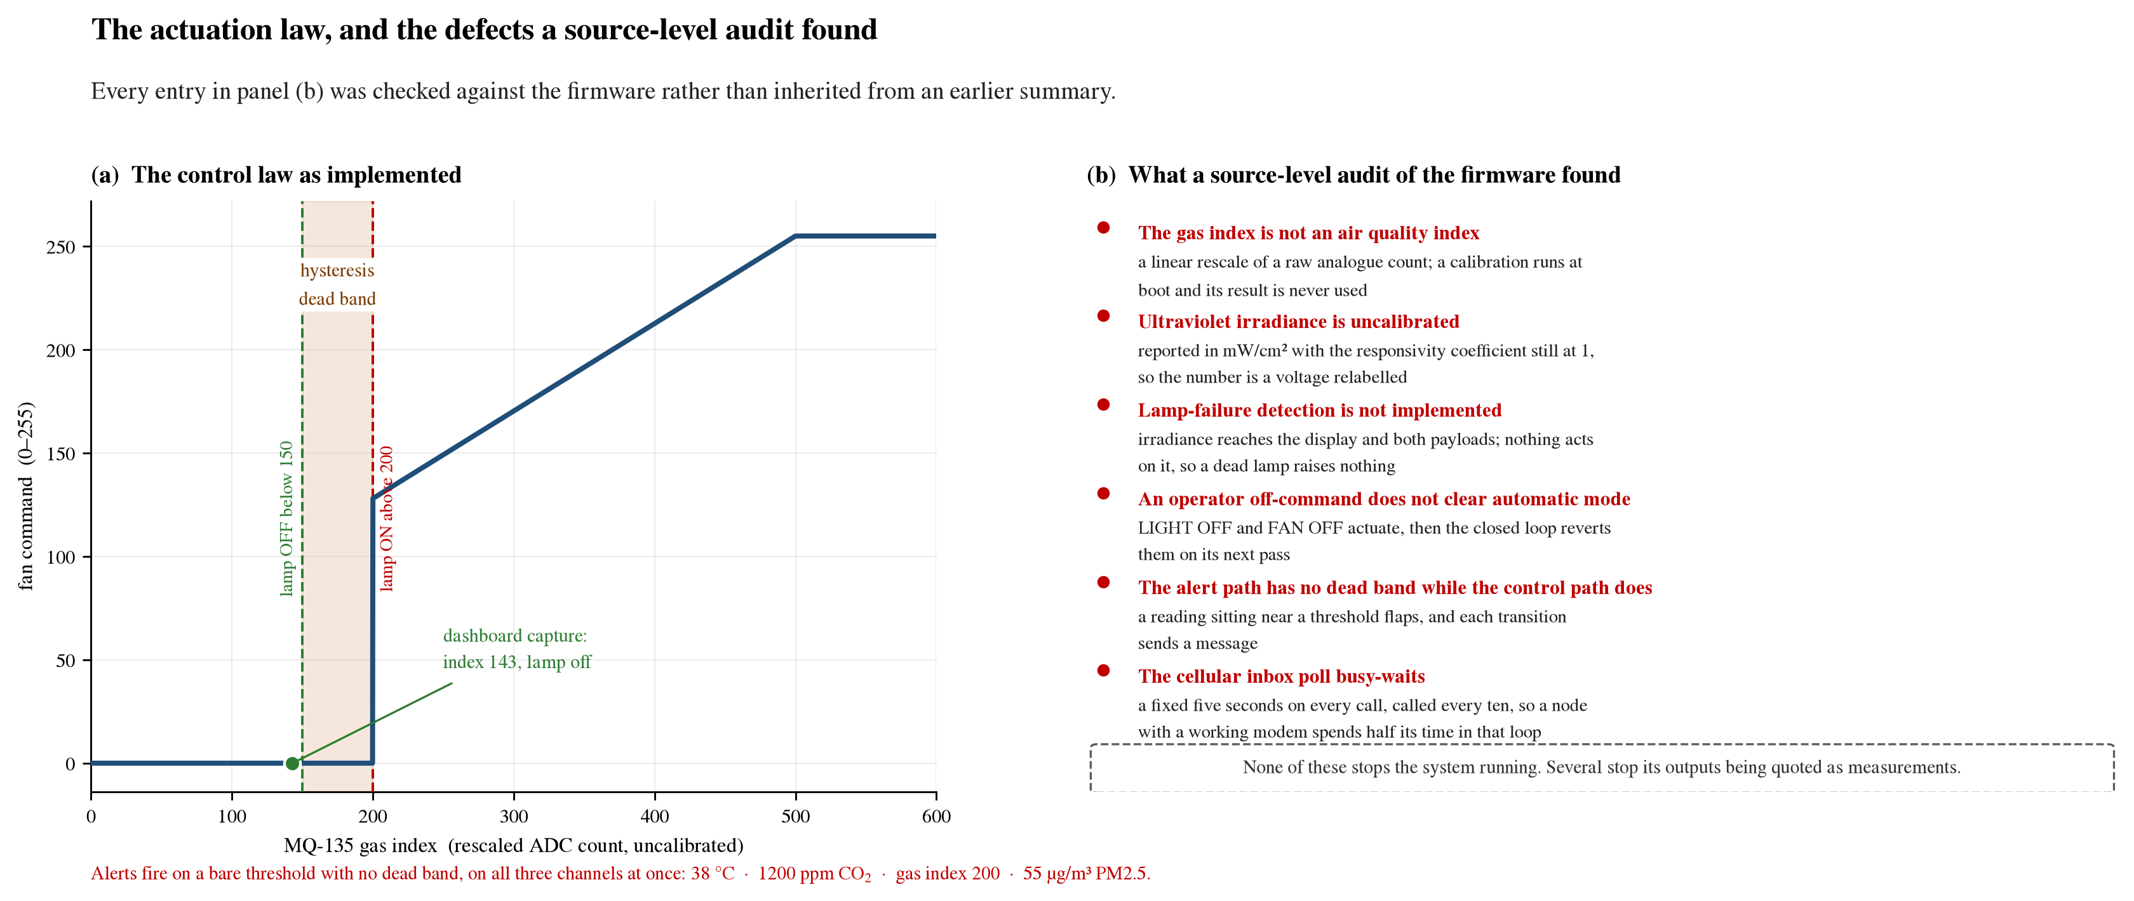
The control law, and what a source audit of it found
Figure 18. Panel (a) is the actuation law as implemented. The lamp switches on above a gas index of 200 and off below 150, and the fan is ramped rather than switched, starting at half command at the lamp-on threshold and reaching full command at an index of 500. Panel (b) is what a source-level audit of the firmware found, listed as defects rather than as features. Every entry was checked against the code; one claim in earlier circulation, that the fan tachometer never divides by its sample window, was checked and found to be wrong, and the residual error there is a small high bias from loop latency.
The index driving all of this is a rescaled analogue count rather than a concentration. A calibration routine for that sensor runs at first boot, computes a value, stores it, and the control law never reads it. As a control input the raw index is adequate, since the thresholds were set against it and it moves in the right direction when the air worsens. As a reported quantity it is not, and no number derived from it should be quoted as a concentration in any publication.
The alert path is separate from the control path and is not built the same way. A breach fires simultaneously on all three channels, a clearing message follows on the same three, and the alert state is latched so that a sustained breach does not generate a message on every cycle. Particulate matter is evaluated only when the reading is valid, so a failed sensor never raises a false alarm, and a sensor that fails to respond is transmitted as a negative marker rather than as zero, which keeps a broken particulate sensor distinguishable from genuinely clean air. What the alert path does not have is the dead band that the control path does. It compares a noisy signal against a bare threshold, so a reading sitting near a limit flaps, and each transition sends a message. Figure 19 happens to catch the system 40 ppm above the carbon dioxide threshold, which is well inside that flapping range.
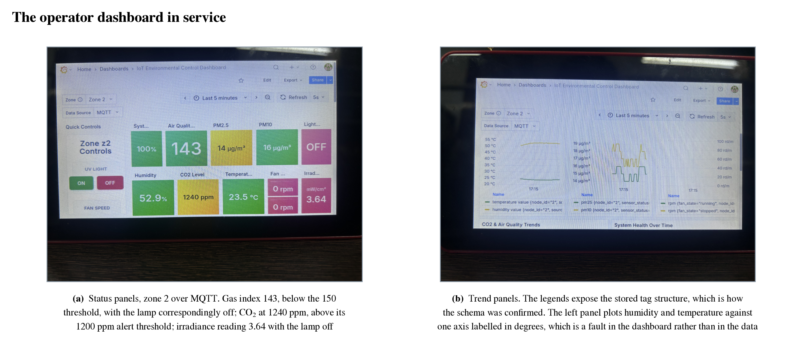
The operator dashboard in service
Figure 19. The operator dashboard in service, photographed rather than captured. Panel (a) is the status view for one zone: the gas index reads 143, below the 150 threshold, with the lamp correspondingly off, while carbon dioxide at the same instant reads 1240 ppm, above its 1200 ppm alert threshold. That is one consistent operating state, and it shows the deployed logic producing the configured actuator and alert states for the inputs present at that instant. Panel (b) is the trend view, whose legends expose the stored tag structure and were used to confirm the database schema.
The operator sees the system through a dashboard served from the local server, twenty-three panels templated per zone so that one layout serves all four installations. Alongside the readings it carries in-panel actuator control, and this is where the most interesting defect lives. An operator command to switch the lamp or the fan off actuates correctly and then does not clear automatic mode, so the closed loop reverts it on its next pass. The on-commands do clear it. Off is precisely the command an operator issues when they want the machine to stop doing what it is doing, and it is the one that does not hold.

2.6 What is deployed, and what it does not yet establish
The monitoring system is deployed and operating across four zones in two radio-isolated installations sharing one database. All three communication channels, both control paths and the dashboards are in service, and the system recovers automatically after a power interruption without intervention.
The control law was checked against the deployed system rather than asserted, although what that check establishes should be stated precisely. A dashboard capture taken during operation shows the gas index below the configured actuation threshold with the lamp correspondingly off, and the carbon dioxide reading at the same instant above its alert threshold with the node having raised an alert on all three channels. That is a single consistent operating state, and it demonstrates that the deployed logic produces the configured actuator and alert states for the inputs present at that instant. It is not a time-resolved measurement of the loop responding to a change, which would require logging the measurement, the threshold crossing, the actuator command and the resulting response on one time axis. That recording has not been made.
Two limitations are recorded plainly rather than left in a defect register. The gas index that drives the present control law is a relative signal rather than a calibrated concentration, adequate for actuation and trend observation and not defensible in any quantitative claim. And lamp-failure detection, which is the capability that would distinguish this unit from a timer, is not implemented. The irradiance measurement that would support it is taken, displayed and transmitted; nothing acts on it. A dead lamp currently raises nothing. Both are identified with the specific code paths involved in the project record for that system, and both are in Chapter 4.
One finding from the same audit is worth reporting because it affects timing rather than accuracy and because it explains several symptoms at once. The cellular inbox poll waits a fixed five seconds on every call and is invoked every ten, so a node with a working modem spends roughly half its wall-clock time inside that loop. That is the underlying cause of publish intervals jittering between five and ten seconds and of dashboard commands taking up to five seconds to act. It is about six lines to fix and is the single highest-value change available in that firmware.

2.7 Towards warehouse management
Developing the monitoring system toward storage applications. The architecture is intended to transfer beyond the unit it was built for. Cold-chain storage, controlled-atmosphere rooms used for produce ripening, and general warehouse environmental survey call for the same measurement set and the same resilience to intermittent connectivity, although the system has so far been deployed in one application and transferability is a design expectation rather than a demonstrated result. Traceable calibration of the measurement channels and a buffered store-and-forward path, so that an outage costs latency rather than data, are the next steps.
The architecture is already shaped for the wider application. Zones are templated rather than hand-built, the database takes one schema regardless of which transport the data arrived on, and adding an installation means adding a node and a zone identifier rather than rebuilding anything; retargeting a gateway is three constants, and retargeting its service is four values in a configuration file. A facility instrumented this way would know the condition of every storage area continuously rather than by inspection, and would drive treatment from that condition rather than from a timetable.
The step that makes it more than a set of fixed instruments is the one that needs the other strand. Fixed nodes measure the places they are bolted to, and a warehouse has far more places than anyone will instrument. A robot that already traverses every aisle, carrying the same sensor complement, samples the spaces between the fixed nodes and reports into the same database on the same schema. That turns a handful of point measurements into something closer to a survey. It needs the navigation layer of Chapter 1 finished first, which is why it sits where it does in the plan of Chapter 4 rather than being attempted now.

Chapter 3 Contactless Assessment of Worker Fatigue

3.1 The problem, and the goal
This chapter is short, and the reason is that the work it describes has not been done. The strand consists of a hypothesis, a completed literature survey and a research proposal built on them. No hardware has been built, no data has been collected, and nothing has been measured. It is carried in this report because the argument is already specific enough to state, to criticise and to test, and because the first year of a doctorate is the right time to establish whether a direction is worth the next three.
The setting is the third thing in the aisle. India’s logistics and warehousing sector employs over 22 million people, is expanding under the National Logistics Policy of 2022, and records more than 26,800 workplace incidents a year. Nearly 70 per cent of that workforce is in the unorganised sector, where occupational health protocols are minimal or absent. The conditions make fatigue worse rather than merely present: shifts of ten to twelve hours, sustained walking and lifting, and ambient temperatures that routinely exceed 40 °C. Occupational heat stress in Indian workplaces has been measured directly, with documented exceedances of established thresholds and associated health and productivity consequences [23], and comparable findings are reported across steel [24], construction [25] and multi-sector southern-Indian settings [26]. Figure 20 sets the two halves of the problem side by side.
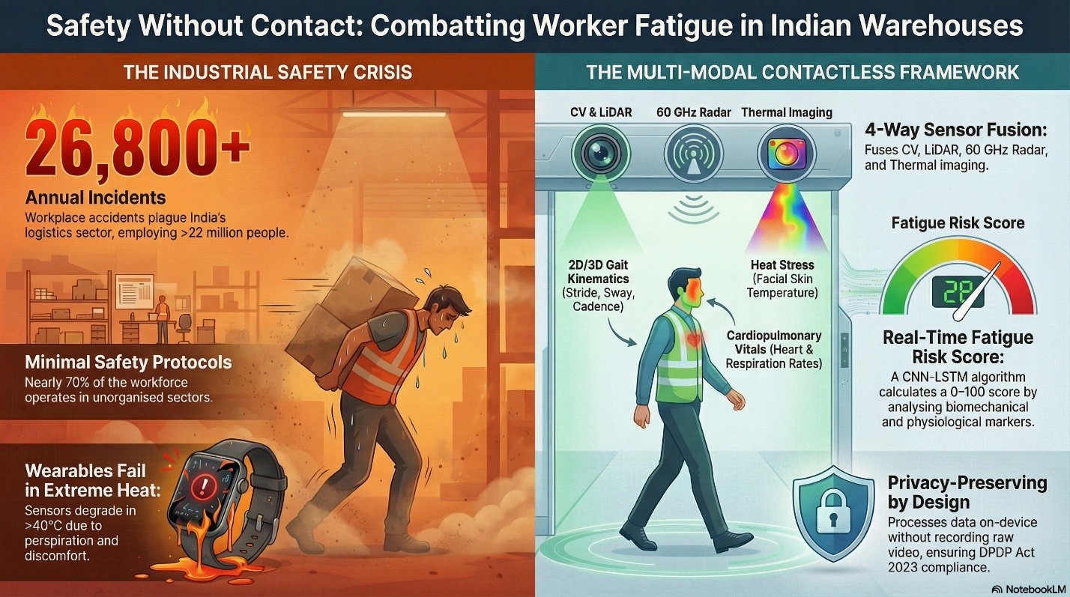
The problem, and what a contactless node would watch
Figure 20. The case for the strand, set out side by side: on the left the conditions that make fatigue a safety problem in Indian warehouses, and on the right what a contactless node would watch instead. The wearable on the left is the point of the whole approach. A device that degrades in heat and perspiration, and that a worker has to choose to put on, is not a measurement system for an eight-hour shift. This figure was generated with an AI tool from the text of the research proposal for this strand, and is included as a summary rather than as evidence.
Fatigue monitoring as currently practised does not transfer to this setting. The established laboratory methods are contact-based [30], and the established field systems address seated drivers rather than walking workers [31]. The objections to instrumenting the worker instead of the space are practical rather than evidential, and are given here as the design reasoning behind the approach rather than as findings: a sensor worn against the skin for an eight-hour shift in the ambient conditions described above is uncomfortable, electrode contact and signal quality degrade with perspiration, compliance depends on the worker choosing to wear it, and a facility employing hundreds of people acquires a daily charging and maintenance burden. None of these is fatal alone. Together they are why this strand asks whether the measurement can be made without contact at all.
The goal, stated at its largest, is a warehouse that can tell how hard the people in it are working without asking any of them to wear anything, and can do it continuously rather than at a shift review. The hypothesis underneath it is more specific than that, and it is what makes the strand testable. Physical fatigue is proposed to show itself as a correlated signature across several physiological domains at once: gait regularity deteriorating, heart and respiration rates rising, and facial skin temperature climbing. If that is right, then a system watching all of those at the same time should beat any system watching one of them, and it should beat it hardest under exactly the conditions where single modalities struggle, which are occlusion, heat and an uncontrolled floor.

3.2 Review of Literature
Fatigue detection as currently practised falls into three categories, and each fails the warehouse for a different reason. Subjective instruments, the sleepiness and perceived-exertion scales and the vigilance test, are the accepted references and they interrupt the work they measure, which makes them unusable as a continuous signal. Wearable physiological monitoring solves the continuity problem and creates an adoption one. And contactless sensing, taken modality by modality, has reached real technical maturity without anyone having pointed it at industrial fatigue.
Contact-based fatigue measurement. Surface electromyography combined with inertial measurement is the established laboratory approach and gives good discrimination under controlled conditions: a recent multimodal system fusing both through a hybrid convolutional and recurrent model reports 87.9 per cent accuracy on induced fatigue under leave-one-subject-out validation across 35 participants [30]. The requirement for skin-contact electrodes and per-subject placement is what prevents its use on an operating warehouse floor.
Driver drowsiness systems. The most mature deployed fatigue systems monitor drivers. Thermal facial imaging alone reaches 82 per cent accuracy against observer-rated drowsiness in a driving simulator by tracking forehead and cheek temperature [31], and wearable systems fuse physiological channels for the same purpose [32]. These assume a seated, stationary, forward-facing and cooperative subject at a fixed distance from the sensor. A worker walking an aisle under load satisfies none of those assumptions.
Contactless modalities. Several sensing modalities can observe a person without contact, and their reported accuracies are the starting point for what a fused estimate could achieve. Camera-based pose estimation recovers joint angles and gait parameters from ordinary video, with mean absolute errors against marker-based motion capture of 0.02 s on temporal parameters and 4.0, 5.6 and 7.4 degrees on sagittal hip, knee and ankle angles [33]. Lidar gives three-dimensional gait measurement that is unaffected by illumination, and a point-cloud gait benchmark establishes that the signal carries enough information to identify individuals [34], which is a capability this strand would have to constrain deliberately rather than a feature to exploit. Millimetre-wave radar recovers respiration and heart rates without contact, correlating with a reference sensor at 94 and 80 per cent respectively [35], although those accuracies are established for near-stationary subjects and degrade with body motion, which the surveyed literature treats as an open problem rather than a solved one [36]. Thermal imaging responds to surface temperature and therefore to thermal strain, and has been used to detect exercise-induced fatigue directly [37], subject to the absolute accuracy limits of low-cost sensors.
The gap this strand proposes to address is the fusion of these modalities for whole-body physical fatigue assessment in an uncontrolled industrial environment. No study meeting the criteria used in this review was identified. That review covered the publication record indexed through Crossref and the scite database, searched between June and September 2026 on combinations of fatigue, gait, thermal imaging, millimetre-wave radar and lidar with industrial, occupational and warehouse qualifiers, and admitted peer-reviewed work only. It is a bounded search rather than an exhaustive one, and the claim should be read as such.
The gap is therefore not a shortage of capable sensors. It is that nobody has fused them for this purpose. Existing multi-modal fatigue work is overwhelmingly contact-based or aimed at seated drivers, and the contactless studies are single-modality and laboratory-bound. The second gap is regulatory rather than technical: India’s data protection legislation of 2023 has created real uncertainty about workplace monitoring, and an architecture that extracts a derived score on the device and never transmits raw video is a different legal object from one that streams a camera feed to a server. That distinction is designed in here rather than argued for afterwards.

3.3 The framework proposed
Figure 21 gives the proposed arrangement in one view. Four contactless modalities feed a single edge computing platform, a fused model produces one score per crossing, and that score drives a rest or rotation decision rather than a record. Each modality is there for a specific reason. A camera with on-device pose estimation recovers two-dimensional gait: stride, sway and cadence. A solid-state lidar recovers the same geometry in three dimensions and does not care about the lighting. A millimetre-wave radar at 60 GHz reaches heart and respiration rate through clothing, which neither of the other two can see. And a long-wave infrared camera reads facial skin temperature, which in the ambient conditions described above is likely to carry more information than it would in a temperate facility. Figure 22 reads the same arrangement left to right, with each modality against the indicator it is there to supply.
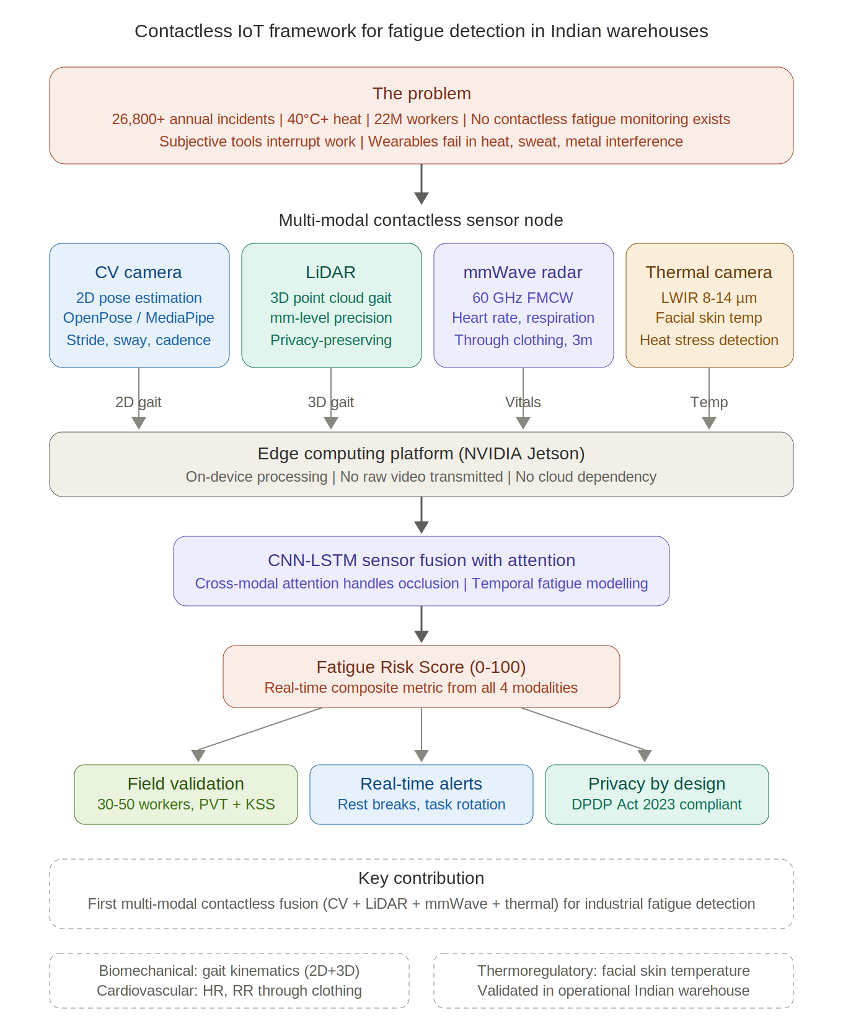
The proposed framework
Figure 21. The proposed framework in one view, reproduced from the research proposal for this strand. Four contactless modalities feed one edge platform, a fused model produces a single score per crossing, and the score drives a rest or rotation decision rather than a record. Nothing below the sensing row exists yet.
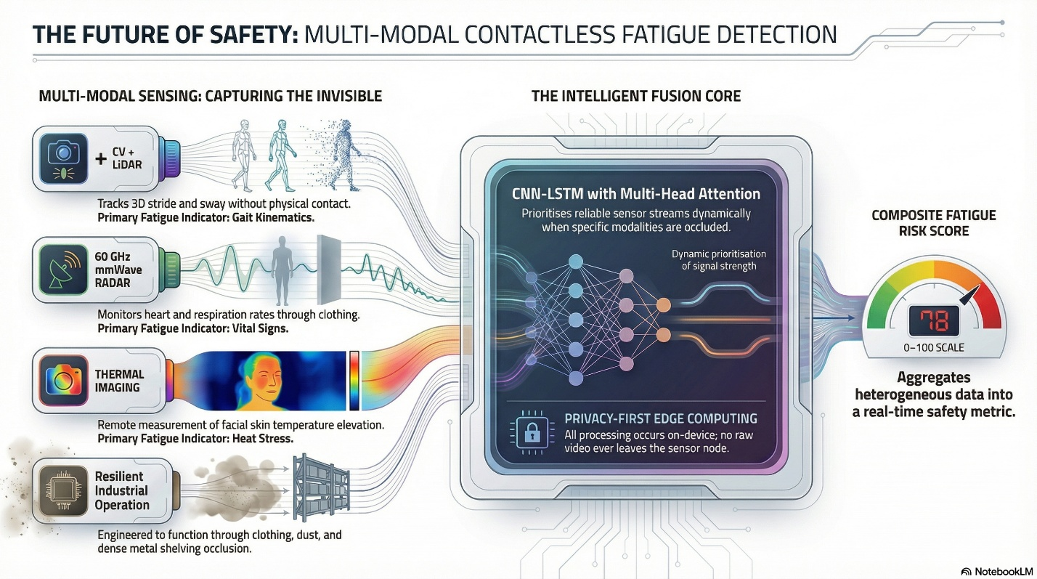
The sensing modalities and the fusion stage
Figure 22. The same framework read left to right: each modality with the fatigue indicator it is there to supply, the fusion stage that weights them against each other when one is occluded, and the single score that comes out. The fourth row on the left is the operating condition rather than a sensor, and it is the one that decides whether any of the rest survives a real floor: clothing, dust and dense metal shelving. This figure was also generated with an AI tool from the proposal text.
Two design decisions are worth drawing out. The capture is fixed and single-subject: rather than tracking several people continuously across a floor, the node sits at one point everybody passes, an aisle end or a doorway, mounted two and a half to three and a half metres up and angled down, working at one to five metres. Each crossing then yields one clean measurement of one person. That trades coverage for tractability, and it is the trade the strand makes deliberately, because continuous multi-person tracking is a harder problem than the one being asked about and solving it is not a prerequisite for answering whether fatigue is legible at all.
The second is that every feature is referred to the worker’s own baseline, recorded at the start of their shift, before it reaches the model. That converts an absolute measurement, which varies enormously between people, into a within-subject change, which is the quantity the question is actually about. The fusion itself is a convolutional branch per stream followed by a recurrent stage over the sequence, with attention across the modalities so that the model can lean on whichever streams are usable when one of them is occluded. It produces a single number per crossing, computed on the node, and no raw video leaves it.
There is one constraint the design has to respect rather than exploit. Gait carries enough information to identify a person, and the point-cloud benchmark cited in Section 3.2 exists to demonstrate exactly that. A system installed to estimate fatigue must not become a system that recognises individuals, so the pipeline has to discard identity by construction rather than by policy. That is easier to design for at the start than to retrofit, and it constrains which features may be retained and what may be stored.

3.4 How the framework would be validated
Figure 23 sets out the three objectives and, more usefully, what each one would be measured against. The right-hand column is the part that makes the strand falsifiable. Gait from the camera and the lidar is checked against marker-based motion capture, which is an external physical reference rather than another estimate. A subset of volunteers wears surface electromyography on the calf muscles and inertial bands at the same time as the contactless capture, so the proposed method is compared directly against the established contact method it proposes to replace, on the same subjects during the same task. Field deployment then runs in an operational, non-air-conditioned warehouse across thirty to fifty workers and several shifts, scored against the vigilance and sleepiness instruments.
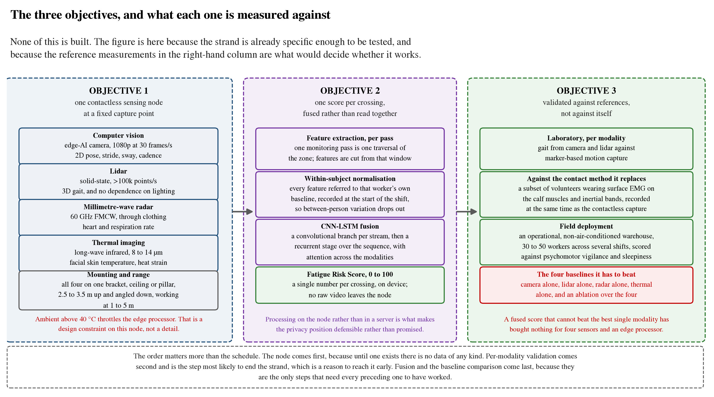
Objectives and the references they are measured against
Figure 23. The three objectives, and the physical reference each one is measured against. The right-hand column is the part that makes the strand falsifiable: each modality is checked against marker-based motion capture or against the contact method it proposes to replace before anything is fused, and the fused score is then required to beat four single-modality baselines and an ablation over them. A fused score that cannot beat the best single modality has bought nothing for four sensors and an edge processor.
The comparison that decides the thing is the last row. The fused score is required to beat four single-modality baselines, camera alone, lidar alone, radar alone and thermal alone, together with an ablation over the four. Setting that bar before any data is collected is deliberate, because it is exactly the comparison that becomes easy to avoid once a pipeline exists and produces plausible-looking numbers. A fused score that cannot beat the best single modality has bought nothing for four sensors and an edge processor.
One practical constraint sits across all of it. Simultaneously processing four high-bandwidth streams on a single edge platform generates heat, and a non-air-conditioned Indian warehouse above 40 °C is precisely where that platform will throttle. That is a design constraint on the node rather than a footnote, and it is one of the reasons the hardware objective has to be completed and tested in situ before the algorithmic one means anything.

3.5 Work done, and what comes next
What exists at the end of the year is the survey, the hypothesis it produced, and a full research proposal built on both. The survey covered sensor modality performance, multi-modal fusion architectures, occupational fatigue physiology, Indian industrial environmental conditions and the data protection position, searched between June and September 2026 across the Crossref and scite indexes on combinations of fatigue, gait, thermal imaging, millimetre-wave radar and lidar with industrial, occupational and warehouse qualifiers, admitting peer-reviewed work only. It is a bounded search rather than an exhaustive one and the gap it identifies should be read as such.
The technical feasibility argument rests entirely on other people’s results, and that is stated rather than blurred. Each of the four modalities has been demonstrated to high accuracy individually by established groups, and fusion using this class of architecture has been shown to outperform single-modality baselines in related fatigue tasks. None of that is evidence that the combination works here. It is evidence that the combination is worth attempting.
Implementing the contactless fatigue framework. This strand currently consists of a hypothesis and a completed literature survey. The implementation begins with a single-subject capture arrangement at a fixed location, such as an aisle end or doorway, so that each crossing yields one clean measurement rather than requiring continuous tracking of several people at once. Laboratory validation of each modality against a direct physical measure of fatigue precedes any deployment, and the fused estimate must be shown to outperform a simple baseline derived from ambient conditions and hours worked before the approach can be considered established.
The sequence matters more than the schedule. The capture node comes first, because until one exists there is no data of any kind. Per-modality laboratory validation comes second and is the step most likely to end the strand, which is a reason to reach it early rather than late: if two of the four modalities carry no usable fatigue signal on walking subjects, the design changes before anything is built around them. Fusion, the field deployment and the baseline comparison come last, because they are the only steps that need every preceding one to have worked.

Chapter 4 Conclusions and Objectives for the Years Ahead

4.1 What the first year established
The year produced a full-scale asymmetric mecanum platform with calibrated wheel-level control, an implementation of the non-collinear kinematics verified against an independent reference, wheel odometry characterised against physical floor marks, a measured account of the scanner’s limitations, a preliminary demonstration of autonomous navigation, and a deployed environmental monitoring system operating across four zones.
Four results are established rather than asserted. The velocity controller tracks to 0.040 to 0.047 rad/s root-mean-square unloaded and 0.066 to 0.074 under chassis weight, with no channel saturating in any recorded run. The kinematic and odometry implementations are numerically consistent to machine precision across twenty thousand generated cases and against an offline re-integration of a complete drive. Wheel-odometry endpoint closure stays below 1 per cent of path to about 10 m and sits between 1.1 and 1.5 per cent on the longest routes driven. Scan matching was measured to increase pose error on three separate routes, most tightly on a drive where the same wheels and the same scans gave 16.2 mm unmatched and 206.7 mm matched, with corrections firing on a fixed odometry cadence rather than on scan disagreement.
The monitoring strand adds a fifth, of a different kind. A complete system was taken from nothing to a deployment running unattended across four zones in two radio-isolated installations sharing one database, with three concurrent communication channels, two control paths and automatic recovery from a power interruption. That is an engineering result rather than a measured one, and the report is careful in Section 2.6 about the difference: the deployed logic has been shown to produce the configured states for the inputs present at an instant, and has not been shown responding to a change on a single time axis.

4.2 What remains open, and why
Three things remain unresolved, and the reasons differ. A commissioning map meeting all four acceptance criteria and localisation against a saved map are blocked by the size of the available test area, not by the platform. The effect of the asymmetric geometry itself is unquantified, because no matched symmetric baseline has been built. And several degrees of heading error survive every instrument currently fitted, narrowed to an encoder or wheel-radius scale error or a rigid all-wheel slip mode, which cannot be separated without an independent angular-rate measurement.
The question Year 2 tests follows directly from the last of those. Adding inertial measurement to a platform whose unfused behaviour is now characterised gives a specific quantity to test the improvement against, rather than a general expectation that fusion helps.
Open items on the other two strands are smaller in scope but not in importance. The monitoring system reports a gas index that is a rescaled analogue count rather than a calibrated concentration; reports an ultraviolet irradiance whose responsivity coefficient is still set to one, so the figure is a voltage relabelled; has an operator off-command that the automatic law reverts on its next pass; and does not implement the lamp-failure detection that its irradiance measurement exists to support. All four are documented against the specific code paths involved, all four are fixable, and none should be carried into a second year. The fatigue strand has nothing to correct because it has nothing built, which is itself the thing to change.

4.3 Objectives for the years ahead
The plan runs one strand at a time rather than all three at once, and Figure 24 lays it out. Each strand is carried on its own until it stands up by itself, and only then do they meet. That ordering is a judgement rather than a convention: a strand whose behaviour has not been characterised alone contributes nothing measurable to a combined system, and combining early would mean three partly-understood components whose failures could not be told apart.
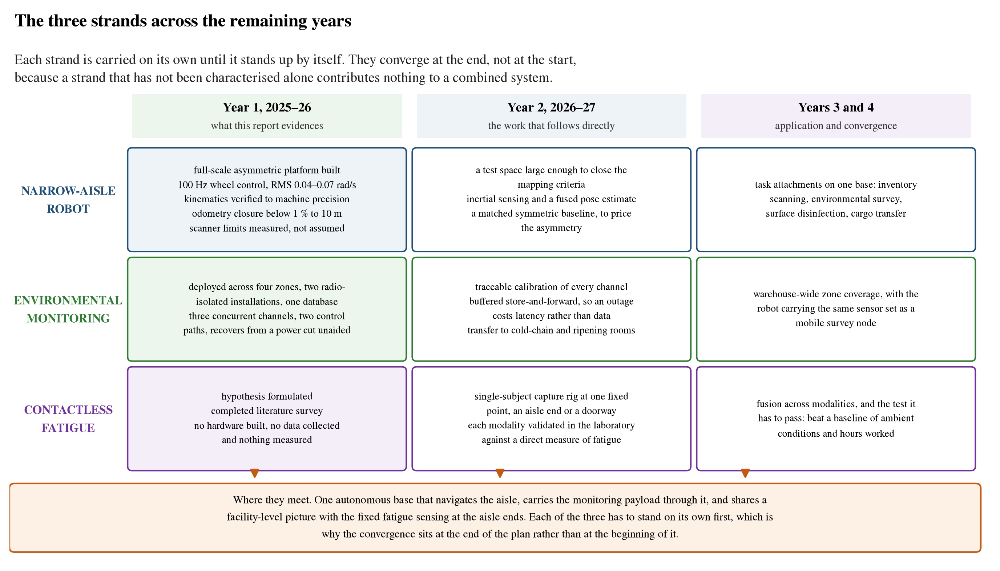
The three strands across the remaining years
Figure 24. The three strands across the remaining years. Each is carried on its own until it stands up by itself, and the convergence sits at the end rather than the beginning, because a strand that has not been characterised alone contributes nothing measurable to a combined system.
The robot. Five things follow directly from Chapter 1, and they are given here in the order in which they unblock each other.
Securing a representative test space. The coverage limitation of Section 1.13 is the binding constraint on the mapping and localisation layers, and it is environmental rather than technical. A continuous traversable loop with unobstructed wall on at least one side and aisle widths representative of the application is required before the commissioning criteria can be assessed meaningfully. An initial target of fifteen to twenty metres of path is proposed, on the grounds that it is several times the few metres currently available rather than derived from a measured coverage-accumulation rate. Arranging access to such a space is the first practical task.
Inertial measurement and fused state estimation. The photogrammetric result of Section 1.13 leaves two candidate explanations for several degrees of heading error that every fitted instrument misses: an encoder or wheel-radius scale error, which calibration can remove, or a rigid slip mode in which all four wheels slip together, which it cannot. Separating them needs an angular-rate measurement that does not derive from the wheels. Adding an inertial sensor near the geometric centre, where the rotationally induced terms in the accelerometer channel are smallest, and fusing its integrated rate with the wheel estimate is the direct response, and for the reason given in Section 1.15 it is the right next step rather than something that should have come first. The 3.85° and 4.49° already measured give a specific quantity against which the improvement can be tested.
Sensor comparison. The case against the present lidar is now quantitative rather than impressionistic. Repeating the same routes with a higher-grade scanner, using the same analysis tools, would convert that inference into a controlled result and would establish what sensing this class of platform actually requires. That question is currently answered in the literature by convention rather than by measurement.
Completing the geometric comparison. No asymmetry-specific penalty has been detected in any experiment performed so far: the transformation is implemented correctly to the limit of double precision, tracking is clean on every axis including lateral and rotational motion, endpoint closure holds below 1 per cent on the three logged drives up to 10.61 m and to 1.1 to 1.5 per cent on the longest routes driven, and no yaw-consistency residual above the episode threshold has been observed. A matched symmetric baseline has not been tested, so the effect of the asymmetry itself remains unquantified. What has not been performed is a controlled side-by-side comparison against a symmetric layout of matched mass, wheel and controller parameters. Building that baseline, in simulation first and on hardware if the wheelbase can be reconfigured without a new chassis, would convert a consistent absence of penalty into a measured result and would close Objective 3.
Extending the platform to warehouse tasks. The chassis is intended as a general-purpose autonomous base, with task capability delivered by attachments. Inventory scanning, environmental survey, surface disinfection and cargo transfer are the intended applications, and each requires integration work on top of the autonomy layer rather than changes to it.
The monitoring system. Four items, in order of how much each one changes what the system can honestly claim. The gas channel has to be driven from the calibration that is already computed and stored rather than from a rescaled count, and the ultraviolet channel has to be calibrated against a reference radiometer at a fixed geometry, because until both are done no measurement from the unit can be quoted as a quantity. Lamp-failure detection comes next and is the capability that distinguishes the unit from a timer: once the relay has been closed longer than the lamp strike time, irradiance above a threshold should be required, and its absence should raise an alert. Third, the cellular inbox poll has to stop blocking the main loop, which is roughly six lines and fixes the command latency and the publish jitter at the same time. Transfer to cold-chain and controlled-atmosphere rooms comes fourth, and is the point at which the architecture is tested against an application it was not built for.
The fatigue strand. The sequence is set out in Section 3.5 and is not repeated here, except for the one decision that belongs in a plan rather than in a chapter. The per-modality laboratory validation, and in particular the comparison against surface electromyography on the same subjects during the same task, is scheduled early, in the second year, specifically because it is the step most likely to show that the approach does not work. A negative result reached in year two is a useful contribution and leaves time to act on it. The same result reached in year four is not.

4.4 Where the three converge
The end state this project is aimed at is one facility that knows three things about itself at the same time: where its autonomous machines are and what they are carrying, what the air is doing in every storage area rather than at a handful of instrumented points, and how hard the people sharing those aisles are working. Each of the three chapters above is one of those, taken far enough that it can be measured on its own terms.
The mechanism by which they join is not a piece of integration software. It is that the robot becomes the mobile element of the monitoring system, carrying the same sensor complement through the spaces no fixed node will ever be bolted to and reporting into the same database on the same schema, while the fatigue sensing sits at the aisle ends the robot is already navigating between. None of that requires anything to be invented. It requires the navigation layer to be finished, the monitoring channels to be calibrated, and the fatigue pipeline to have been shown to work, which is the content of the three plans above.
The honest summary of the position at the end of year one is that the first strand has a built machine and a set of measured limits, the second has a running system and a list of defects it should not carry forward, and the third has an argument. Year two turns the first into a robot that navigates a saved map, the second into a system whose numbers can be quoted, and the third into data. Only then is there anything to converge.

Bibliography
1. Arunkumar, G. K., Devkar, S., Vachhani, L., & Kunwar, A. (2024). An omnidirectional asymmetric mobile robot for narrow aisle spaces. 2024 Tenth Indian Control Conference (ICC), IISER Bhopal, India, 18–23.
2. Galati, R., Mantriota, G., & Reina, G. (2022). Adaptive heading correction for an industrial heavy-duty omnidirectional robot. Scientific Reports, 12(1), 19608.
3. Lin, L.-C., & Shih, H.-Y. (2013). Modeling and adaptive control of an omni-mecanum-wheeled robot. Intelligent Control and Automation, 4, 166–179.
4. Cao, G., Zhao, X., Ye, C., Yu, S., Li, B., & Jiang, C. (2022). Fuzzy adaptive PID control method for multi-mecanum-wheeled mobile robot. Journal of Mechanical Science and Technology, 36(4), 2019–2029.
5. Vlantis, P., Bechlioulis, C. P., Karras, G., Fourlas, G., & Kyriakopoulos, K. J. (2016). Fault tolerant control for omni-directional mobile platforms with 4 mecanum wheels. IEEE International Conference on Robotics and Automation, 2395–2400.
6. Macenski, S., & Jambrečić, I. (2021). SLAM Toolbox: SLAM for the dynamic world. Journal of Open Source Software, 6(61), 2783.
7. Grisetti, G., Stachniss, C., & Burgard, W. (2007). Improved techniques for grid mapping with Rao-Blackwellized particle filters. IEEE Transactions on Robotics, 23(1), 34–46.
8. Kohlbrecher, S., von Stryk, O., Meyer, J., & Klingauf, U. (2011). A flexible and scalable SLAM system with full 3D motion estimation. IEEE International Symposium on Safety, Security and Rescue Robotics, 155–160.
9. Heß, W., Kohler, D., Rapp, H., & Andor, D. (2016). Real-time loop closure in 2D LIDAR SLAM. IEEE International Conference on Robotics and Automation, 1271– 1278.
10. Konolige, K., Grisetti, G., Kümmerle, R., Burgard, W., Limketkai, B., & Vincent, R. (2010). Efficient sparse pose adjustment for 2D mapping. IEEE/RSJ International Conference on Intelligent Robots and Systems, 22–29.
11. Laksono, P. S., & Kusuma, T. M. (2022). Performance analysis of Hector SLAM and GMapping for mobile robot navigation. Jurnal Ilmiah Teknologi dan Rekayasa, 27(2), 144–153.
12. Sugiura, K., & Matsutani, H. (2021). An FPGA acceleration and optimization techniques for 2D LiDAR SLAM algorithm. IEICE Transactions on Information and Systems, E104.D(6), 789–800.
13. Sugiura, K., & Matsutani, H. (2022). A universal LiDAR SLAM accelerator system on low-cost FPGA. IEEE Access, 10, 26931–26947.
14. Censi, A. (2008). An ICP variant using a point-to-line metric. IEEE International Conference on Robotics and Automation, 19–25.
15. Grisetti, G., Kümmerle, R., & Stachniss, C. (2010). A tutorial on graph-based SLAM. IEEE Intelligent Transportation Systems Magazine, 2(4), 31–43.
16. Moravec, H., & Elfes, A. (1985). High resolution maps from wide angle sonar. IEEE International Conference on Robotics and Automation, 116–121.
17. Macenski, S., Martín, F., White, R., & Ginés Clavero, J. (2020). The Marathon 2: A navigation system. IEEE/RSJ International Conference on Intelligent Robots and Systems.
18. Lu, D. V., Hershberger, D., & Smart, W. D. (2014). Layered costmaps for context-sensitive navigation. IEEE/RSJ International Conference on Intelligent Robots and Systems, 709–715.
19. Fox, D., Burgard, W., & Thrun, S. (1997). The dynamic window approach to collision avoidance. IEEE Robotics and Automation Magazine, 4(1), 23–33.
20. Li, X., Liu, F., & Liu, J. (2017). Obstacle avoidance for mobile robot based on improved dynamic window approach. Turkish Journal of Electrical Engineering and Computer Sciences, 25, 666–676.
21. Williams, G., Drews, P., Goldfain, B., Rehg, J. M., & Theodorou, E. A. (2016). IEEE Aggressive driving with model predictive path integral control. International Conference on Robotics and Automation, 1433–1440.
22. Williams, G., Drews, P., Goldfain, B., Rehg, J. M., & Theodorou, E. A. (2018). Information-theoretic model predictive control: theory and applications to autonomous driving. IEEE Transactions on Robotics, 34(6), 1603–1622.
23. Venugopal, V., Chinnadurai, J., Lucas, R. A. I., & Kjellstrom, T. (2016). Occupational heat stress profiles in selected workplaces in India. International Journal of Environmental Research and Public Health, 13(1), 89.
24. Krishnamurthy, M., et al. (2017). Occupational heat stress impacts on health and productivity in a steel industry in Southern India. Safety and Health at Work, 8(1), 99–104.
25. Dutta, P., et al. (2015). Perceived heat stress and health effects on construction workers. Indian Journal of Occupational and Environmental Medicine, 19(3), 151– 158.
26. Balakrishnan, K., et al. (2010). Case studies on heat stress related perceptions in different industrial sectors in southern India. Global Health Action, 3, 5635.
27. Guo, Y., Chen, X., Gong, P., et al. (2023). Advances in postharvest storage and preservation strategies for Pleurotus eryngii. Foods, 12(5), 1046.
28. Hui, P. S., Wong, L. T., & Mui, K. W. (2008). Using carbon dioxide concentration to assess indoor air quality in offices. Indoor and Built Environment, 17(3), 213– 219.
29. Mašić, A., Bibić, D., & Pikula, B. (2019). Evaluation of carbon dioxide sensors for indoor air quality monitoring. Proceedings of the 30th DAAAM International Symposium, 457–459.
30. Hwang, S., Kwon, N., Lee, D., et al. (2025). A multimodal fatigue detection system using sEMG and IMU signals with a hybrid CNN-LSTM-attention model. Sensors, 25(11), 3309.
31. Tashakori, M., Nahvi, A., & Ebrahimian, S. (2021). Driver drowsiness detection using facial thermal imaging in a driving simulator. Proceedings of the Institution of Mechanical Engineers, Part H: Journal of Engineering in Medicine, 236(1), 43– 55.
32. Kartsch, V., Benatti, S., Schiavone, P. D., Rossi, D., & Benini, L. (2018). A sensor fusion approach for drowsiness detection in wearable ultra-low-power systems. Information Fusion, 43, 66–76.
33. Stenum, J., Rossi, C., & Roemmich, R. T. (2021). Two-dimensional video-based analysis of human gait using pose estimation. PLoS Computational Biology, 17(4), e1008935.
34. Shen, C., Fan, C., Wu, W., et al. (2023). LidarGait: benchmarking 3D gait recognition with point clouds. IEEE/CVF Conference on Computer Vision and Pattern Recognition, 1054–1063.
35. Alizadeh, M., Shaker, G., & Almeida, J. C. (2019). Remote monitoring of human vital signs using mm-wave FMCW radar. IEEE Access, 7, 54958–54968.
36. Zhang, J., Xi, R., & He, Y. (2023). A survey of mmWave-based human sensing: technology, platforms and applications. IEEE Communications Surveys and Tutorials, 25(4), 2052–2087.
37. Bordallo López, M., del-Blanco, C. R., & García, N. (2017). Detecting exercise-induced fatigue using thermal imaging and deep learning. IEEE International Conference on Image Processing Theory, Tools and Applications, 1–6.

